Contents
How to Draw Manga Eyes 3
Step 1: Draw the Eye Shape 3
Step 2: Add the Iris 3
Step 3: Draw the Pupil 3
Step 4: Add the upper lid 4
Step 5: Add Light Reflections 4
Step 6: Draw the Eyelashes 4
Step 7: Add details and shade 4
Step 8: Add the Eyebrow 5
How to Draw Manga Hair 7
Step 1: Start with the Head Shape 7
Step 2: Sketch the Hairline and Flow 7
Step 3: Add Hair Clumps 8
Step 4: Outline the Hair Shape 8
Step 5: Add Details Inside the Hair 8
💇‍♀️ Examples of Basic hair styles 9
How to Draw Manga Mouths 10
Step 1: Draw a Horizontal Line for the Base 10
Step 2: Adjust for Expression 10
👄 Examples of Manga Mouths 11
How to Draw Manga Noses 12
Step 1: Mark the Nose Position 12
Step 2: Suggest Shadows or Lines (Optional) 12
How to Draw Manga Faces 13
Step 1: Draw a Circle and Guideline, and define the jawbone 13
Step 2: Place the eyes, nose, mouth and ears 13
Step 3: Experiment with Angles 13
Step 4: Add the Neck and Shoulders 14
How to draw Manga Anatomy (Proportions & Posing) 15
Step 1: Draw the Head 15
Step 2: Mark 7.5-8 Heads Down the Page 15
Step 3: Mark the Key Body Landmarks 16
Step 4: Sketch the Limbs with Simple Lines 17
Step 5: Add Simple Shapes Over the Limbs 19
Step 6: Tidy Up the Body Shape 20
🧍‍♂️ Basic body movements 21
How to Draw Manga Hands 22
Step 1: Start with the Palm Shape 22
Step 2: Mark the Knuckles 22
Step 3: Draw the Fingers 22
✋ Examples of Manga Hands 23

How to Draw Manga Eyes
Manga eyes are highly expressive and vary by style (shōnen, shōjo, chibi, etc.). This tutorial teaches a simple front-facing eye in 6 clear steps.

Step 1: Draw the Eye Shape
Start by drawing an arched upper lid and a flatter or curved lower lid.
Make the eye wide and open — manga eyes are typically much larger than realistic eyes.
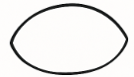

Step 2: Add the Iris
Inside the eye shape, draw a large oval or circle that fills most of the space vertically and touches or overlaps the eyelids slightly.
Don’t centre it too much — slightly up or down placement creates more emotion.
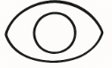

Step 3: Draw the Pupil
Inside the iris, add a dark circle for the pupil.
This should sit at the centre of the iris and be noticeably smaller.
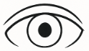

Step 4: Add the upper lid

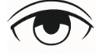

Step 5: Add Light Reflections
To make the eyes appear shiny and alive, add light reflections
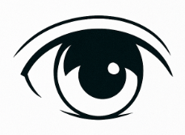

Step 6: Draw the Eyelashes
Thicken the upper eyelid line and extend it slightly past the edges.
You can also add a small flick upward at the outer edge for a lash effect.
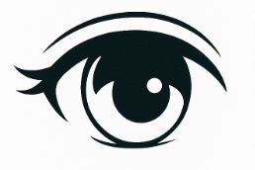

Step 7: Add details and shade

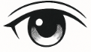

Step 8: Add the Eyebrow
Draw a soft arch or line above the eye — not too close.
Eyebrows help define emotion:
- Curved = calm
- Angled = intense
- High = surprised

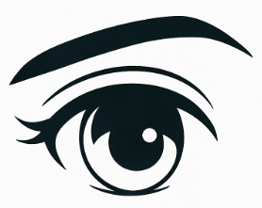

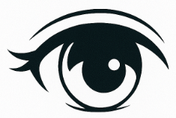 Examples of Manga eyes, with eyebrows

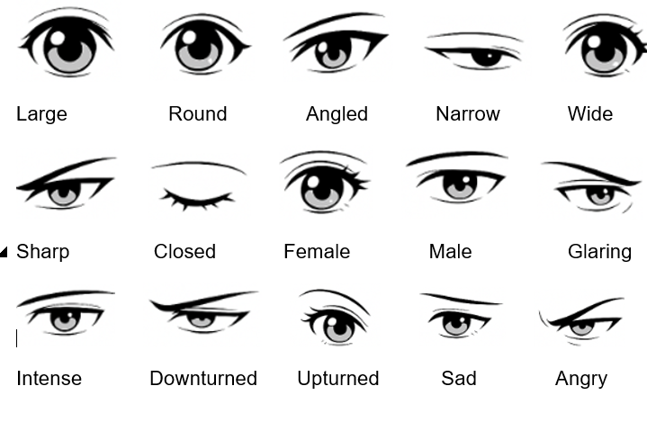

How to Draw Manga Hair
In manga, hair follows a few clear rules:
- It flows in clumps, not individual strands.
- It follows the shape of the skull, but often exaggerates for style.
- It can reflect personality — wild, smooth, spiky, soft, or stiff.

Step 1: Start with the Head Shape
Use a simple circle and jawline. This gives you the base to build your hair onto.
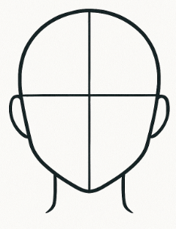

Step 2: Sketch the Hairline and Flow
Lightly sketch a hairline — usually follows a soft “M” shape or arch above the forehead.
Then draw the general direction the hair will fall, using light curved lines to map flow.
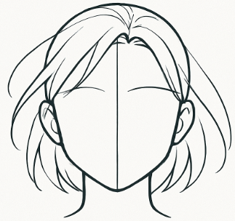

Step 3: Add Hair Clumps
Sketch big, curved clumps of hair instead of individual strands. Think of each clump like a ribbon or leaf—tapered at the ends and wider in the middle.
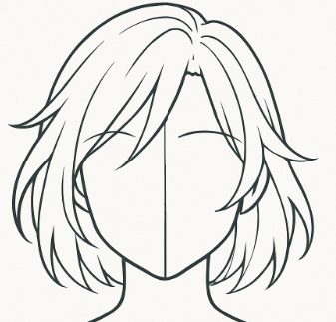

Step 4: Outline the Hair Shape
Using your clumps as a guide, create the full hair silhouette. Let it extend slightly beyond the head — hair has volume and doesn’t cling to the skull.
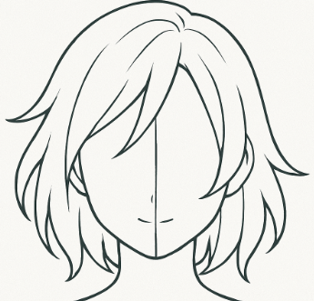

Step 5: Add Details Inside the Hair
Draw internal lines that follow the direction of the clumps. These give the hair texture and help guide where highlights or shadows will go.
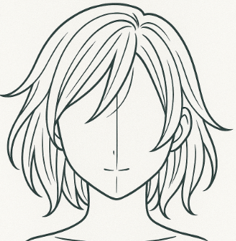

💇‍♀️ Examples of Basic hair styles

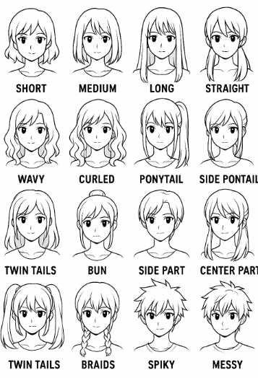

How to Draw Manga Mouths
Manga mouths are simple but expressive. The shape, size, and placement vary depending on mood, gender, and style. This tutorial shows how to draw a neutral front-facing mouth, step by step.

Step 1: Draw a Horizontal Line for the Base
Start with a short, slightly curved horizontal line halfway between the nose and chin. This is the base of the mouth.
Above the base line, draw a short curved line that suggests the top lip. Keep it small and light.
Below the base line, draw a slightly longer, soft curve to suggest the lower lip. This adds shape and volume.
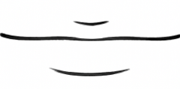
Join up the lines
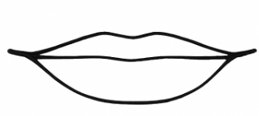

Step 2: Adjust for Expression
To change mood:
- Curve the ends up for a smile
- Curve the ends down for a frown
- Add a small line at each corner to show tension or softness
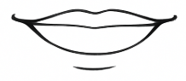

👄 Examples of Manga Mouths
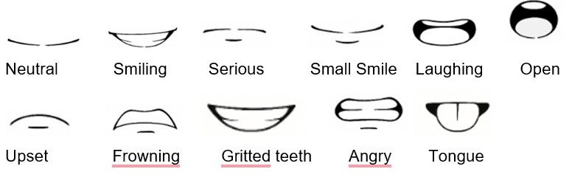

How to Draw Manga Noses
Manga noses are often very simple — especially in front view. The complexity increases slightly in profile or 3/4 view. This tutorial focuses on basic front-facing noses.

Step 1: Mark the Nose Position
Place a small dot or dash along the centre guideline of the face, about halfway between the eyes and mouth. This will mark the base of the nose.
Use a small dash, dot, or tiny curve to suggest the nostrils or tip of the nose. In manga, less is more.
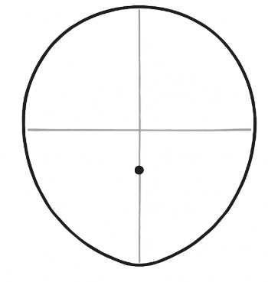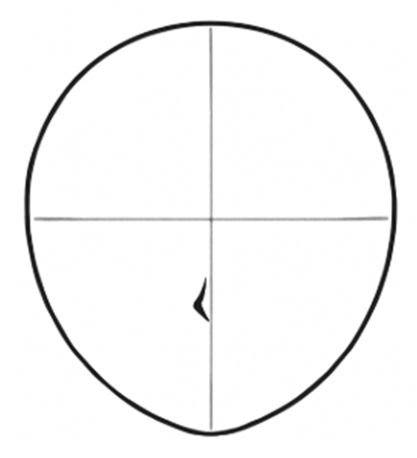

Step 2: Suggest Shadows or Lines (Optional)
Add a tiny line to one side of the nose or under it to suggest shadow. This adds depth without over-detailing.
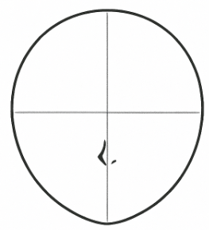

How to Draw Manga Faces

Step 1: Draw a Circle and Guideline, and define the jawbone
Start with a circle and draw a vertical and horizontal line crossing through the centre. This will help place the features evenly.
Define the jawbone
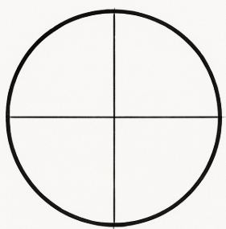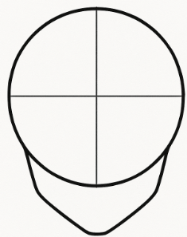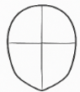

Step 2: Place the eyes, nose, mouth and ears
Eyebrows sit above, and eyes sit below the horizontal guideline. Place two almond or oval-shaped eyes, spaced one eye-width apart.
The nose is small and sits along the vertical guideline. For front views, a small dot or dash is enough. For side views, use a small triangle or curve.
Place the mouth halfway between the nose and chin. Keep it simple—just a soft curve or a slight “w” shape for a smile.
Ears sit between the eyes and nose, on the sides of the head.
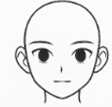

Step 3: Experiment with Angles
Try drawing faces from different angles (3/4 view, profile, up/down tilt) using the same guidelines.
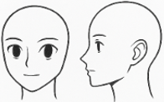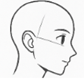
Don’t forget the hair!
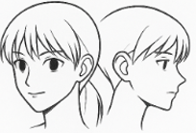

Step 4: Add the Neck and Shoulders
- From just under the ears, draw two lines curving slightly inward for the neck.
- Then draw two slanted lines outward from the base of the neck to form the shoulders.
- Keep the lines soft and light — you can adjust them later depending on the character’s build or clothing.

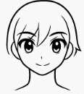

How to draw Manga Anatomy (Proportions & Posing)

Step 1: Draw the Head
Start with a simple oval or circle to represent the head. This will be used as the unit of measurement for the body.
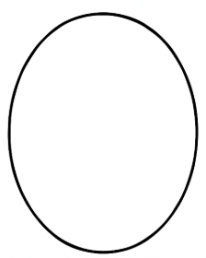

Step 2: Mark 7.5-8 Heads Down the Page
From the bottom of the head, draw 7 more head-lengths stacked below. This gives the full body height. The final half-head unit allows for foot space or stylised proportions.
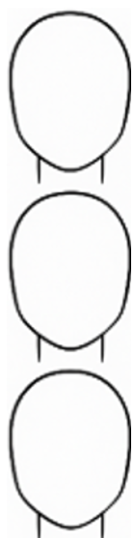

Step 3: Mark the Key Body Landmarks
Use your head units to mark:
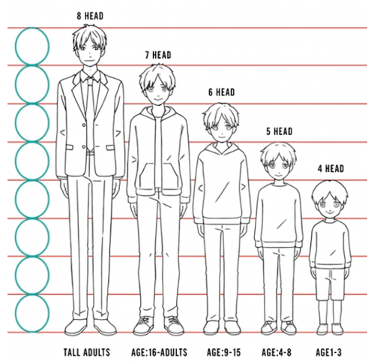

📏 Why Manga Characters Look Extra Tall
- Proportions: Many manga use the 7 or 8-heads-tall rule, while real people average about 6.5 to 7 heads tall.
- A 7- or 8-head manga adult doesn’t look abnormally tall — it looks refined
- Legs are longer: Manga often exaggerates long legs to make characters look more elegant or powerful.
- Style choice: Taller, slender figures fit dramatic action scenes, fashion, and emotional expression.
- A 4-head child reads instantly as adorable or young, even if it’s anatomically impossible
- The rules shift by genre — shōnen heroes are tall and lean; chibi forms are the opposite
If you’re drawing a realistic adult, 6.5–7 heads is fine. For stylised manga, go for 7–8 heads — it’s not realistic, but it looks great on the page. Want a side-by-side comparison of manga vs real-world proportions?
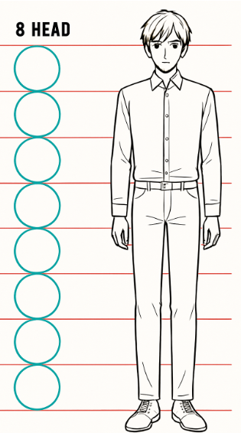

👶 Children vs Adults
- Young children in manga = ~4 heads tall
- Teens = 6–7 heads tall
- Stylised adults = 7–8 heads tall (or more!)

Step 4: Sketch the Limbs with Simple Lines
Use straight or slightly curved lines to block in:
- Arms: from shoulders to just above the 4th head unit (elbows), ending at mid-thigh
- Legs: from hips to 6th head (knees), down to 7.5th (feet)
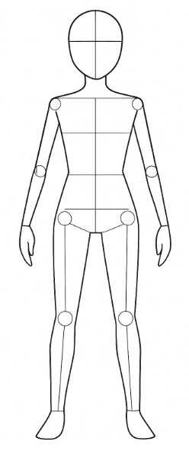

Step 5: Add Simple Shapes Over the Limbs
Now add:
- Cylinders for arms and legs
- Ovals for joints
- Wedge or block shapes for the chest and hips
This makes it easy to turn the stick figure into a body.
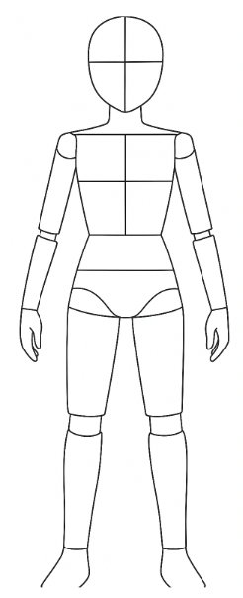

Step 6: Tidy Up the Body Shape
Use your simple forms to draw a smooth outline for the body. This is your final base sketch.
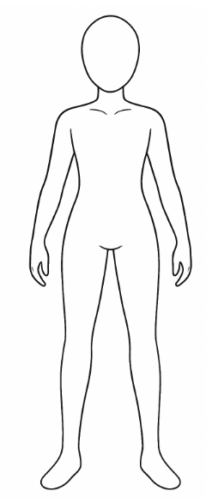

🧍‍♂️ Basic body movements
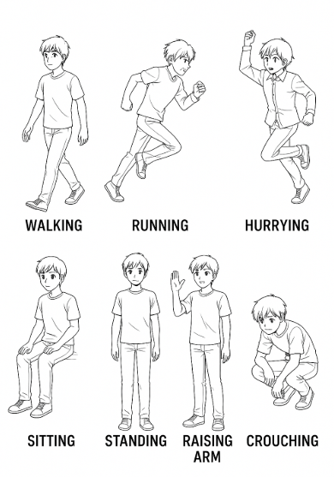

How to Draw Manga Hands
Hands are tricky — but with a simplified approach, they become manageable. This tutorial breaks down front-facing open hands using basic shapes and proportions.

Step 1: Start with the Palm Shape
Draw a rounded rectangle or square. This represents the palm — not perfectly square, but slightly longer than wide.
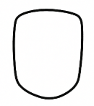

Step 2: Mark the Knuckles
Draw a gentle arc across the top of the palm. This shows where the fingers will attach — they're not in a straight line.
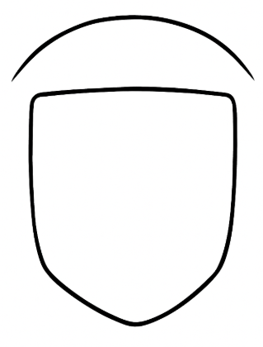

Step 3: Draw the Fingers
From the knuckle arc, draw four fingers using simple rectangles or sausages.
- Middle finger is longest
- Index and ring are a bit shorter
- Pinky is the smallest
Add the thumb, and the details

✋ Examples of Manga Hands

