📘 What Is an Art Zine?
An art zine is a self-published, DIY mini book that artists use to express themselves. These booklets often feature:
- Drawings and illustrations
- Short stories or poems
- Collages and mixed media
- Personal reflections or themes
Art zines are typically made by folding a single sheet of paper into a booklet, making them accessible and easy to create.

🎨 Why Are Art Zines Great?
Art zines offer a fantastic outlet for you to:
- Express yourself creatively without constraints.
- Experiment with different art forms and ideas.
- Share your creations with friends and family.
- Build confidence in your artistic abilities.

✂️ How to Make a Simple Art Zine
Creating an art zine is fun and straightforward. Here's a basic method:
- Materials Needed:
- One sheet of A4 or letter-sized paper
- Scissors
- Pens, pencils, markers, or any art supplies
- Folding the Paper:
- Fold the paper in half lengthwise, (hot dog style), then unfold.
- Fold it in half width wise, (hamburger style), then unfold.
- Fold each short edge to the centre crease, creating eight equal sections.
It should look like this:
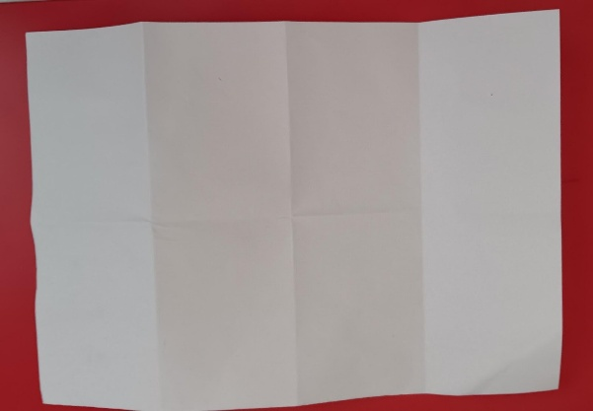

- Fold in half width wise, with the fold towards you
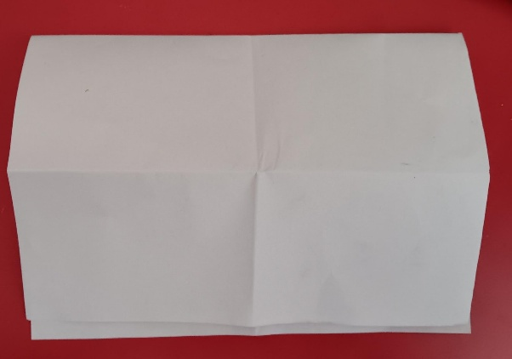
- Cut from the bottom line (ie. from the folded edge), half way to the middle line
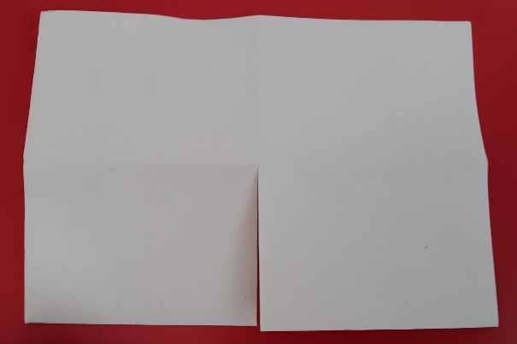
- Fold the paper lengthwise again and push the ends toward each other, forming a booklet.

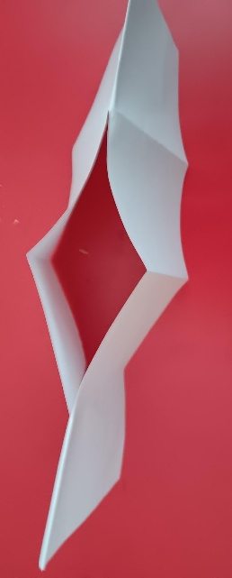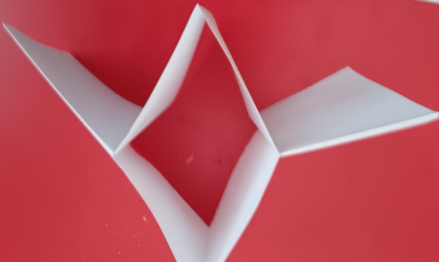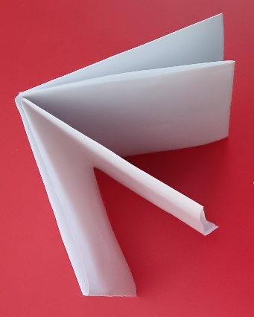

- Filling Your Zine:
  - Use each page to draw, write, or collage.
  - Choose a theme or let your imagination guide you.

Creating an Artist project?
You can use a Vine to share your Artist project, here’s one as an example: https://www.instagram.com/p/C8KdZvXCUNy/

