🎨 Acrylic Painting Basics – Tutorial 1: What Are Acrylic Paints?
Step 1: Meet the Paints
- Acrylic paints are thick, colourful paints made with plastic (acrylic polymer) and pigment.
- When they dry, they become waterproof and don’t smudge.
- You can use them on canvas, paper, wood, or even rocks!
Step 2: Why Choose Acrylic?
- They dry faster than oil paints.
- You can clean up with just water (while the paint is still wet).
- Great for layering and bright colours.
Step 3: What You’ll Need
- A basic set of acrylic paints
- A paintbrush or two (round and flat)
- A palette (plastic plate works!)
- A cup of water and some paper towels
- A surface to paint on (paper, canvas board, etc.)
- An old shirt or apron to protect clothes
Step 4: Play with the Paint
- Squeeze out red, yellow, and blue.
- Try mixing them to make orange, green, and purple.
- Test how the paint feels: is it thick? Smooth? Fast to dry?

🎨 Acrylic Painting Basics – Tutorial 2: Setting Up Your Workspace
Step 1: Choose a Good Spot
- Find a space with good light and a flat surface.
- Put down newspaper or a plastic cloth to protect the table.
Step 2: Gather Your Materials
You'll need:
- Acrylic paints
- A palette (or a plate)
- Brushes (flat and round)
- A cup of water
- Paper towels or a cloth
- Your painting surface (paper, board, canvas)
Step 3: Set It All Out Neatly
- Place your palette to one side (whichever hand you don’t paint with).
- Keep your water cup nearby.
- Lay out brushes and paint tubes within easy reach.
Step 4: Protect Yourself
- Wear an apron or old clothes – acrylic paint won’t come out once dry!
- Tie back long hair and roll up sleeves.
Step 5: Get Comfortable
- Sit or stand, whichever is more comfortable.
- Make sure your paper or canvas is taped down or on a sturdy easel.
Step 6: Check Before You Start
- Is there enough light?
- Do you have everything nearby?
- Are you ready to have fun?

🎨 Acrylic Painting Basics – Tutorial 3: How to Hold and Use Different Brushes
Step 1: Know Your Brushes
There are many kinds, but these are great for beginners:
- Flat brush – wide and square, good for big areas and bold strokes.
- Round brush – has a point, good for lines and small details.
- Fan brush – spreads out like a fan, great for trees, grass, or texture.
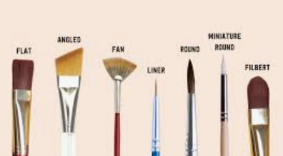
Step 2: How to Hold Your Brush
- Hold it like a pencil for small, careful strokes.
- Hold it further back for big, sweeping movements.
Step 3: Dipping Your Brush
- Dip only the tip of your brush in paint.
- Don’t scoop too much – it will drip and be hard to control.
- Swirl it gently in water to rinse and dry it on paper towel before switching colours.
Step 4: Try These Strokes
- Flat brush:
  - Try long, smooth strokes for skies and backgrounds.
  - Use the edge to make lines or corners.
- Round brush:
  - Try dots, thin lines, and curves.
- Fan brush:
  - Lightly dab or sweep to make texture, like leaves or fur.
Step 5: Practise Makes Perfect
On a scrap sheet, try:
- Horizontal lines
- Vertical lines
- Dots
- Swirls
- Big and small strokes

🎨 Acrylic Painting Basics – Tutorial 4: Colour Mixing & Making a Colour Wheel
Step 1: Start with the Primaries
You only need red, yellow, and blue to start.
These are primary colours – you can’t mix them, but you can use them to make all the others!
Step 2: Mix the Secondaries
On your palette, mix:
- Red + Yellow = Orange
- Yellow + Blue = Green
- Blue + Red = Purple
Try to get even amounts first. Then test again using more of one colour to see what happens.
Step 3: Try Tints and Shades
- Tint = Colour + White (makes it lighter)
- Shade = Colour + Black (makes it darker)
Try:
- Red + white = pink
- Blue + black = navy
Step 4: Make a Colour Wheel
- Draw a circle and divide it into 6 sections like a pizza.
- Paint the primary colours in every other space (red, yellow, blue).
- Fill the spaces between them with the secondary colours you’ve mixed.
Step 5: Bonus – Try Complementary Colours
Opposite colours on the wheel are called complementary (like red and green). Put them side by side and see how they stand out!

🎨 Acrylic Painting Basics – Tutorial 5: Blending and Layering Paints
Step 1: Understand Dry Time
- Acrylic paint dries quickly, so you must work fast to blend wet colours.
- Once dry, you can layer on top without smudging the bottom layer.

🌈 Blending While Wet (Wet-on-Wet Technique)
Step 2: Use Two Colours Side-by-Side
- On your canvas, paint a thick stripe of blue, then right next to it a stripe of white.
Step 3: Blend the Edge
- While both are still wet, quickly use a clean brush to gently sweep across the edge.
- You’ll create a smooth gradient between the colours.
- Try it with red and yellow or blue and purple too!

🧅 Layering Paints (Wet-on-Dry Technique)
Step 4: Let the First Layer Dry
- Paint a solid colour (like a red square).
- Wait a few minutes until it’s fully dry.
Step 5: Paint On Top
- Add details like dots, shapes, or brush strokes using a different colour.
- This is great for adding shadows, highlights, or patterns.

🎯 Tips for Success
- Use soft strokes to blend. Don’t scrub!
- Mist your palette with water to keep paints wetter for longer.
- If it dries too fast, try a slow-drying medium or paint in smaller sections.

🎨 Acrylic Painting Basics – Tutorial 6: Painting Textures and Patterns
Step 1: What Is Texture in Painting?
Texture can mean:
- How the paint feels (bumpy, rough, smooth)
- How the paint looks (like fur, bark, or grass)

🖌️ Using a Dry Brush for Rough Texture
Step 2: Try Dry Brushing
- Dip a dry brush into just a little paint.
- Lightly sweep it over the canvas.
- This creates a scratchy, uneven look — great for wood, fur, or rocky surfaces.

🧽 Using Sponges or Dabbing
Step 3: Dab with a Sponge or Paper Towel
- Dab a sponge into paint and tap it onto the canvas.
- Use different colours to create clouds, bushes, or textured backgrounds.

🌀 Making Repeating Patterns
Step 4: Use the End of a Brush or a Cotton Bud
- Dip the end into paint and press dots across the canvas in a pattern.
- Try stripes, swirls, or polka dots.
Step 5: Paint Simple Patterns
- Use a small brush to repeat shapes like:
  - Zigzags
  - Waves
  - Criss-crosses
  - Circles

🎨 Impasto Painting (Thick Paint)
Step 6: Try Using a Palette Knife (or an Old Card)
- Scoop up thick paint and spread it on like butter on toast.
- This gives 3D texture — try it with tree bark, flower petals, or ocean waves!

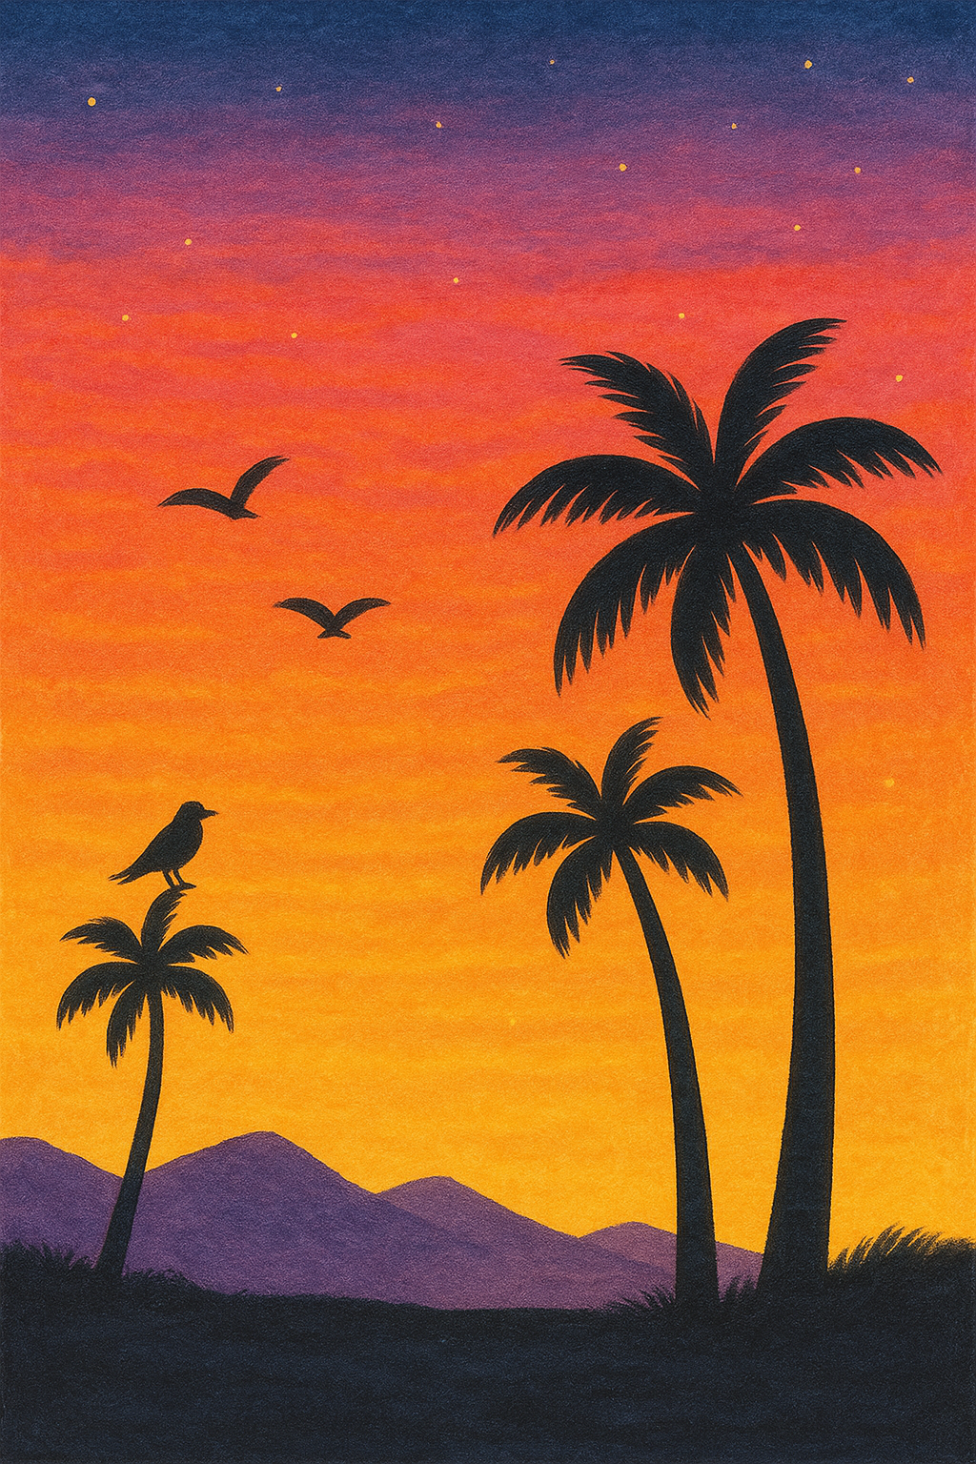
🌇 Tutorial 7: Painting a Sunset Sky with Silhouettes
You’ll Need:
- Acrylic paints: Red, Yellow, Blue, White, Black
- Flat brush, round brush
- Palette, water, paper towel
- Canvas or thick paper

Step 1: Paint the Background Sky
- Mix white + a little yellow to make a soft base.
- Starting at the bottom, paint a stripe of yellow.
- Above it, add orange (red + yellow), then pink (red + white).
- Near the top, blend into purple (red + blue) or dark blue.
🖌️ Work quickly so the edges blend smoothly.

Step 2: Let It Dry
- Wait until the sky is completely dry before adding silhouettes.

Step 3: Add Silhouettes
- Use black paint with a small round brush.
- Ideas: palm trees, birds, mountain shapes, or a child flying a kite.
- Keep it simple — silhouettes are shapes only, no inside detail.

Step 4: Finishing Touches
- Add a few white or light yellow dabs for stars or glowing sky areas if desired.

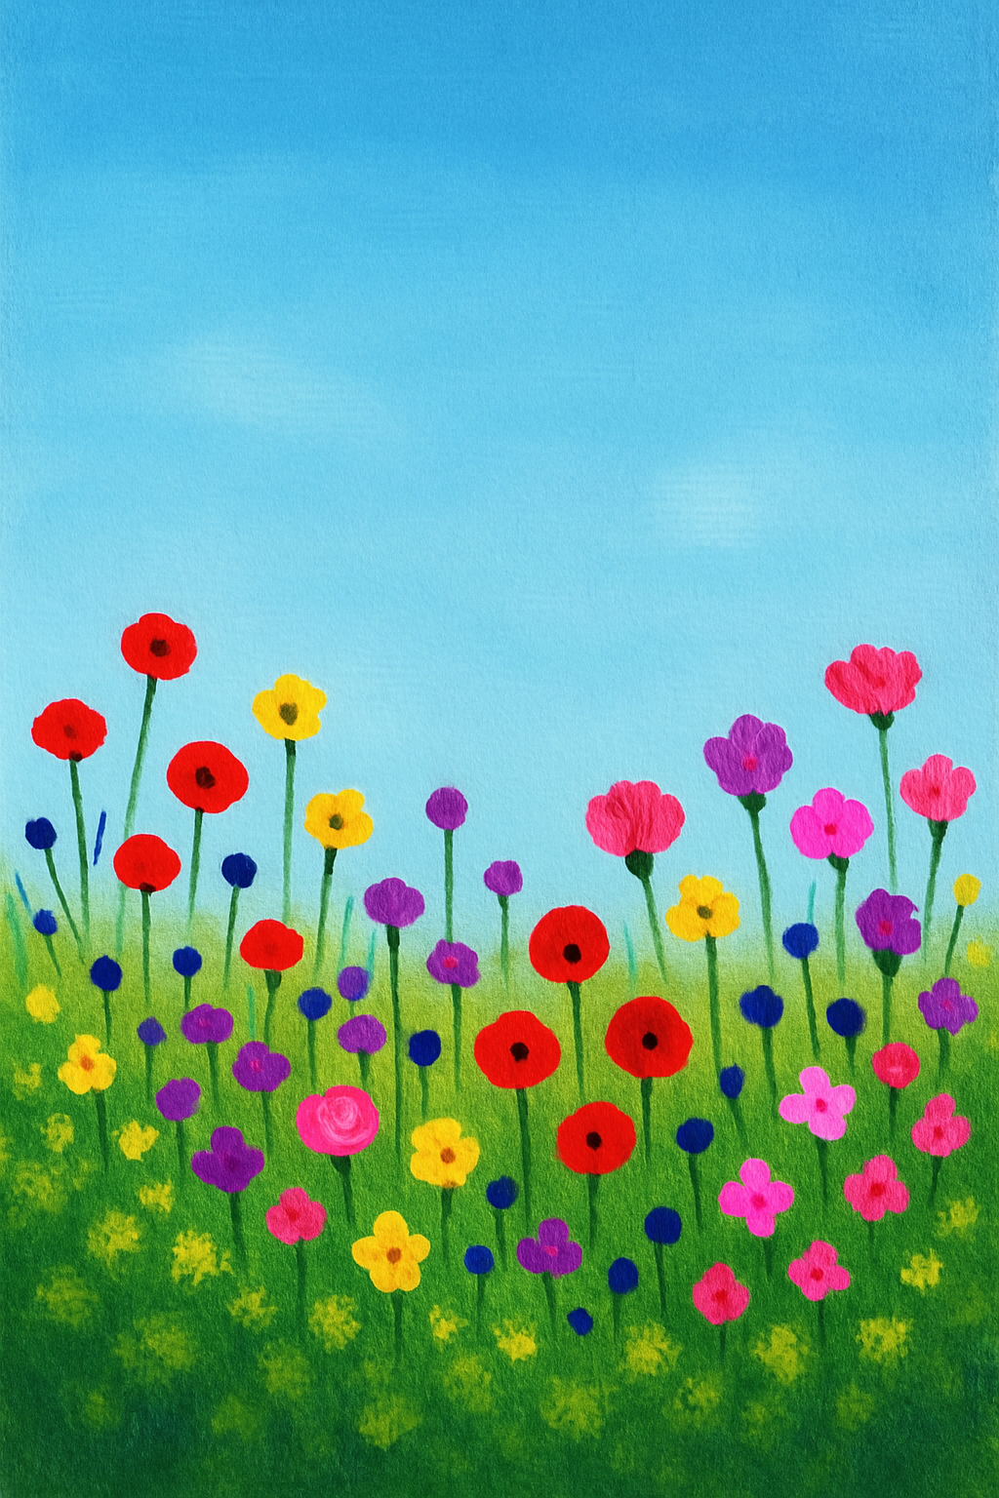
🌸 Tutorial 8: Painting a Field of Flowers
You’ll Need:
- Acrylic paints: Blue, Green, White, Yellow, Red, Pink, Purple
- Flat and round brushes
- Sponge or paper towel
- Canvas or paper

Step 1: Paint the Sky
- Mix blue + white for a sky colour.
- Use a flat brush to paint the top two-thirds of the canvas.
- Blend in a bit of white at the bottom for a soft sky effect.

Step 2: Paint the Grass Field
- Mix different greens (yellow + blue, with white or black to vary).
- Use a sponge or dabbing technique to fill in the bottom third with texture.

Step 3: Add Flower Stems
- Use a thin round brush and dark green to paint lots of tall, thin lines going upward.

Step 4: Paint the Flowers
- Use bright colours like red, yellow, purple, and pink.
- Use a round brush or dab with a cotton bud to make flower shapes:
  - Dots for wildflowers
  - Dabs in a circle for daisy shapes
  - Swirls for roses

Step 5: Add Highlights
- Dab a little white or light yellow in the centre of each flower to make it pop.

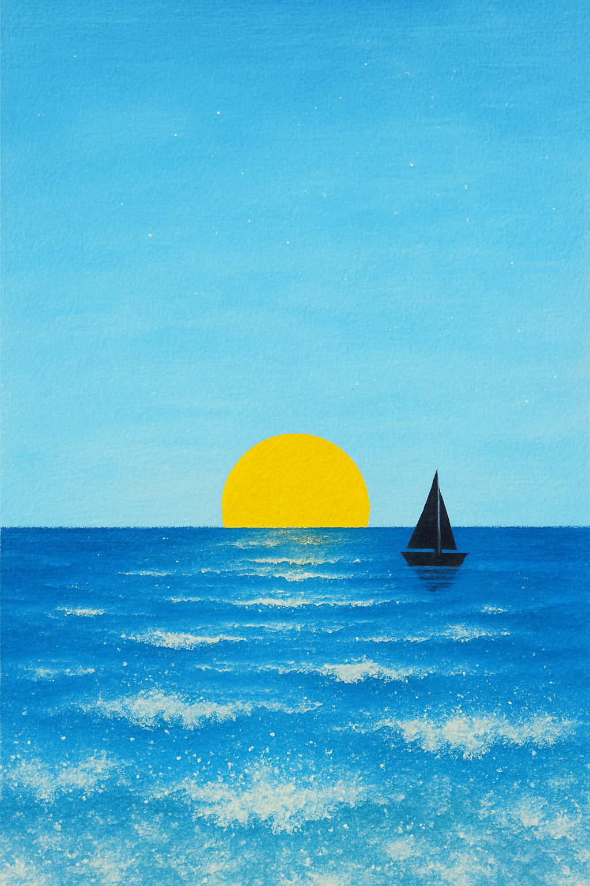
🌊 Tutorial 9: Painting a Simple Ocean Scene
You’ll Need:
- Acrylic paints: Blue, White, Black, Yellow
- Flat brush, round brush
- Sponge or paper towel
- Canvas or paper

Step 1: Paint the Sky
- Mix blue + white for a light sky colour.
- Use a flat brush to paint the top half of your canvas.
- Blend in more white toward the horizon to create a glow.
- Let dry.

Step 2: Paint the Sea
- Mix a deeper blue and paint the bottom half of the canvas.
- Add horizontal strokes to show waves and movement.
- While still wet, blend in white to make wave lines and highlights.

Step 3: Add a Horizon Line
- Use a dark blue or black line where the sea meets the sky.
- Keep it straight and thin – this gives depth.

Step 4: Add Details
- Optional: paint a yellow sun sinking into the water.
- Add white wave crests with a dry brush or dabbing with sponge.

Step 5: Finishing Touches
- Flick white paint gently with a toothbrush to make spray or sparkles.
- Add a tiny boat or seagull shapes if you like!

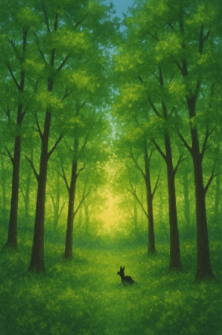
🌳 Tutorial 10: Painting a Forest Scene
You’ll Need:
- Acrylic paints: Green, Brown, Yellow, White, Blue, Black
- Flat brush, round brush, fan brush (optional)
- Sponge or paper towel
- Canvas or paper

Step 1: Paint the Sky Background
- Mix light blue + white for the sky.
- Paint the top third of the canvas.
- Blend in a bit of yellow at the horizon for a morning or evening glow.

Step 2: Add the Ground
- Paint the bottom two-thirds with greens and browns.
- Use a sponge or dabbing brush to make a bumpy, grassy texture.

Step 3: Add Tree Trunks
- Use a thin round brush and brown or black paint.
- Paint vertical lines in different heights for tree trunks.
- Add branches by flicking out thinner lines.

Step 4: Paint the Leaves
- Use a fan brush, sponge, or the tip of a round brush.
- Dab on light green, dark green, and yellow in layers to build leaf textures.
- Let parts of the sky peek through for depth.

Step 5: Extra Details
- Add shadows on one side of the trunks with dark brown or black.
- Use white and green dabs for sunlight patches.
- Optional: paint a small animal silhouette or path through the trees.

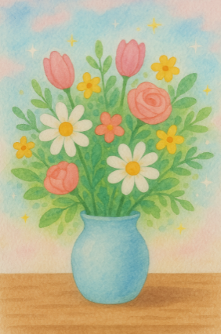
🌼 Tutorial 11: Painting a Vase of Flowers (Still Life)
You’ll Need:
- Acrylic paints: Blue, Yellow, Red, Green, White, Pink, Brown
- Round brush, detail brush
- Canvas or paper
- Pencil for sketching

Step 1: Sketch the Basic Shapes
- Lightly draw an oval for the vase, a table line, and simple circles/ovals for where the flowers will go.

Step 2: Paint the Background
- Choose a soft colour (like light blue or grey).
- Paint the whole background, then let dry.

Step 3: Paint the Vase
- Use a mix of blue + white, or grey, depending on your design.
- Paint shadows on one side and highlights on the other using white.

Step 4: Paint the Table
- Use brown or dark grey to paint a flat surface under the vase.
- Blend in a little black for shadow under the vase.

Step 5: Paint the Flowers
- Use round or small brushes to dab petal shapes using bright colours.
- Try different flower types:
  - Daisies (white petals, yellow centre)
  - Tulips (solid colours, oval petals)
  - Roses (swirling brush strokes)

Step 6: Add Leaves and Stems
- Use a thin brush and mix different greens for variety.
- Paint stems coming down into the vase and leaves poking out between flowers.

Step 7: Highlights and Details
- Add dots of yellow or white for sparkle and brightness.
- Add little touches like a flower petal on the table or a stripe on the vase.

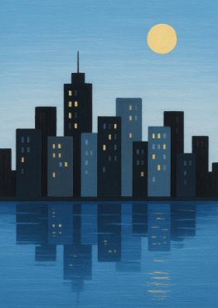
🏙️ Tutorial 12: Painting a Simple Cityscape
You’ll Need:
- Acrylic paints: Black, White, Grey, Blue, Yellow, Red
- Flat brush, round brush, small detail brush
- Canvas or paper
- Ruler (optional)

Step 1: Paint the Sky
- Mix blue + white to create a light sky colour.
- Paint the top half of the canvas using a flat brush.
- Add more white at the bottom for a gradient effect.
🌓 Want a night scene instead? Use dark blue, black, and a touch of purple. Add stars later!

Step 2: Sketch the Skyline (Optional)
- Lightly draw a line across the middle of the canvas for the horizon.
- Sketch a variety of building shapes using rectangles and squares – some tall, some small.

Step 3: Paint the Buildings
- Use black, grey, or dark blue for the building shapes.
- Use a flat brush to fill them in with clean edges.
- Vary the colours and sizes to make it interesting.

Step 4: Add Windows and Lights
- Use a small detail brush or the end of a brush to dot on yellow or white windows.
- Try rows of dots or little rectangles to show lit windows.
- For a daytime city, mix in light grey and white shapes to show reflections.

Step 5: Add Finishing Touches
- Add antennae, rooftop shapes, or a sun/moon in the sky.
- Paint a road or river at the bottom if desired.
- Add a shadow or reflection of the skyline by flipping the shape and painting a faded version below.

🐾 Tutorial 11: Painting a Cute Animal Portrait
You’ll Need:
- Acrylic paints: Brown, Black, White, Pink, Blue, Yellow
- Round and detail brushes
- Pencil (optional)
- Canvas or paper

Step 1: Choose Your Animal
- A simple face works well: cat, dog, fox, bunny, or bear.

Step 2: Light Sketch (Optional)
- Draw a big circle for the head.
- Add ears, eyes, and nose with basic shapes (triangles, circles, ovals).

Step 3: Paint the Background
- Choose a fun colour (e.g., pale blue, grassy green).
- Fill in the entire background and let it dry.

Step 4: Paint the Animal’s Base Colour
- Use brown, orange, grey, or cream depending on the animal.
- Fill in the whole head and ears.

Step 5: Add Facial Features
- Use black or dark brown for eyes and nose.
- Add white dots or sparkles in the eyes to make them shine.
- Use pink for ears or cheeks to make it cute.

Step 6: Add Texture and Fur
- Use short strokes in slightly different shades for a furry look.
- Blend around the edges for softness.

Step 7: Final Details
- Add a little blue collar, bow tie, or flower crown for fun.
- Sign your painting!

