My Second Book of Nursery Rhymes
A Read-and-Colour Adventure!
Step back into the enchanting world of rhythm, rhyme, and imagination with My Second Book of Nursery Rhymes — the perfect companion to the original favourite!
This beautifully designed colouring book features 12 more beloved traditional rhymes, from Rock-a-bye Baby to Hey Diddle Diddle and beyond. Each rhyme is paired with a detailed, black-line illustration on a crisp white background, ready for children to colour and bring to life.
As children read, rhyme, and colour their way through each page, they’ll enjoy a creative experience that is truly their own.
Perfect for ages 3–11, this book supports:
- Creativity and self-expression
- Early reading and language rhythm
- Fine motor skill development
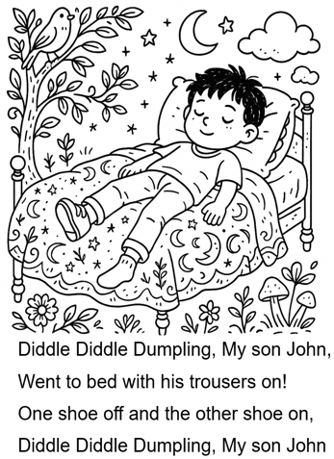
Whether at home, in the classroom, or on the move, My Second Book of Nursery Rhymes makes storytelling interactive, artistic, and full of joy.
Page example
Contents: Traditional Nursery Rhymes Book 2
Cobbler, cobbler, mend my shoe
Diddle Diddle Dumpling, my son John
Here we go round the Mulberry Bush
Hey diddle diddle
Hickory dickory dock
Horsey, horsey, don’t you stop
I’m a little teapot
Little Bo-Peep
Mary, Mary, quite contrary
Rock a bye Baby
Seesaw Margery Daw
There was an old woman who lived in a shoe

