Timeless Flowers from Classic Paintings invites you to explore the beauty of art history through a collection of elegant floral illustrations inspired by the great works of the past.
Each page transforms a classic painted bloom into a clear, sophisticated line drawing ready for you to bring to life with colour.
From delicate garden flowers to lush bouquets found in masterpieces across the centuries, this book offers a calming and creative escape for artists of all ages, who appreciate art, beauty and botanical detail.
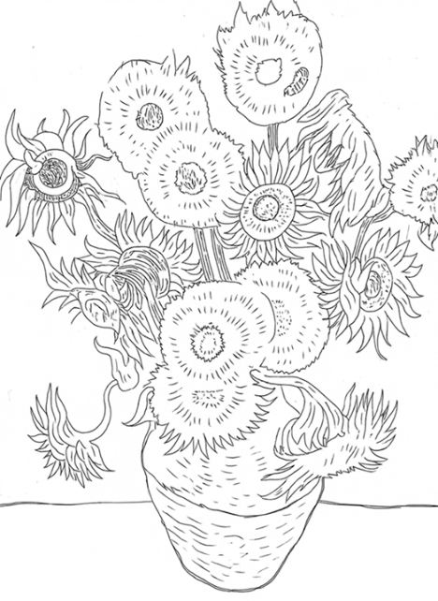
Ideal for mindfulness, relaxation and artistic expression, find a peaceful moment and add your own colours to these classics.
For details of our other books, see www.artsawardinitiative.co.uk
Page example:
Contents list
Bakufu Ono, Turtle Dove and cherry
Charles Rennie Mackintosh, Bouquet
Claude Monet, Bouquet of sunflowers
Claude Monet, Japanese bridge
Damien Hirst, Apple Blossom
Daniel Ridgway Knight, Poppies
Edouard Manet, Bouquet of flowers
Flower garden, Gustav Klimt
Georgia O’Keeffe, Red Canna
Georgia O’Keeffe, White bird of paradise
Hugh Cameron, Buttercups and daisies
John Constable, Flowers in a glass vase
John Singer Sargent, Carnation, Lily, Rose
John William Waterhouse, The soul of the rose
Marianne North, A Brazilian climbing shrub and hummingbird
Michael Ancher, Girl with sunflowers
Pablo Picasso, Boy with bouquet of flowers in his hand
Pierre August Renoir, Girl with watering can
Pierre-August Renoir, Bouquet of roses
Piet Mondrian, Amaryllis
Rachel Ruysch, Flower still life
René François Ghislain Magritte, Almond blossom
Takashi Murakami, Field of smiling flowers
Thomas Baker, First bouquet
Tsuchiya Koitsu, Geisha and cherry tree at Ueno Park
Vincent van Gogh, Still Life with Irises
Vincent van Gogh, Sunflowers

