My Colouring Book: My Fourth Book of Nursery Rhymes
Step into a world of rhythm, rhyme, and creativity with My Fourth Book of Nursery Rhymes!
This delightful colouring book brings another 12 traditional nursery rhymes to life.
Each page features beautifully illustrated scenes, perfect for little hands to colour. Children can read along with the rhymes while using their imagination to fill the pictures with colour, making every page truly their own!
Perfect for ages 3–11, this book encourages:
Creativity and self-expression
Early reading and rhyme recognition
Fine motor skill development
Whether it’s at home, in the classroom, or on the go, My Own Book of Nursery Rhymes is a magical way to blend story time and colouring fun in one joyful experience.
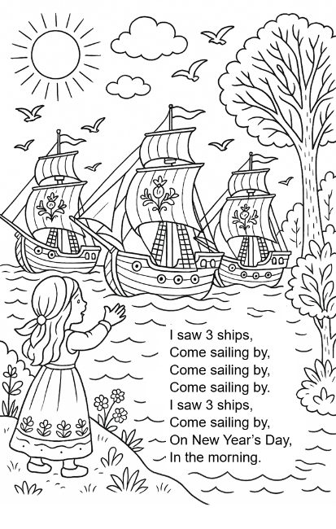
Page example
Contents list

30 days hath September
Girls and boys come out to play
I had a little nut tree
I saw 3 ships
Jack be nimble
Lavender’s blue
Little Miss Muffet
Little Tommy Tucker
Pussy cat, pussy cat
Rub a dub dub
The Queen of hearts
This little piggy

