Discover a world of timeless beauty with My Colouring Book: Landscapes from Famous Paintings.
This unique colouring collection brings iconic landscape artworks to life in a way artists of all ages can enjoy.
Each page transforms a celebrated masterpiece into a clean, elegant line drawing, ready for you to colour.
Whether you’re seeking a relaxing, creative escape, a mindful art activity, or an inspiring introduction to classic landscape art, this book offers something special.
Enjoy mountains, coastlines, fields and forests inspired by great artists, all reimagined for colouring, without losing their original charm.
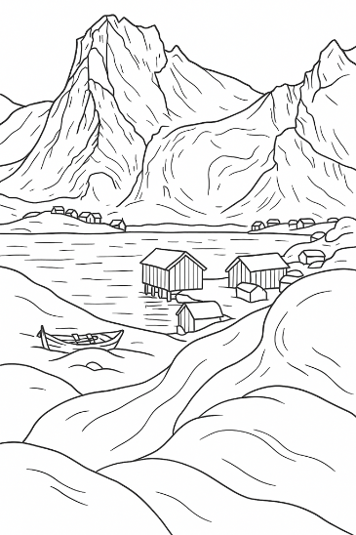
Perfect for quiet moments, art lessons, rainy days, or gifts for creative people of all ages.
Please see our other books at: www.artsawardinitiative.co.uk
Page example:
Contents list
Alexander Nasmyth, A view of Tantallon Castle
Alfred Sisley, The path to the Old Ferry at By
Anna Boberg, An arctic spring day, Study from North Norway
Anon, Under a Pine tree, watching a waterfall
Camille Pissarro, Fox Hill, Upper Norwood
Claude Monet, Impression, Sunrise
David Hockney, Garrowby Hill
Émile Henri Bernard, Paysage avec deux Bretonnes et vache
Émile Henri Bernard, Epoque de Pont Aven
Émile Henri Bernard, Vue des Toits
Fernand Leger, The City
Georges Braque, Houses at Estaque
Georges Braque, The Viaduct
John Constable, The Vale of Dedham
Katsushika Hokusai, Yoro waterfall in Mino Province
Kazimir Malevich, Morning in the village after a snowstorm
Khayrudinov Anvar, Old Istanbul, Sultanahmet Mosque
Paul Cezanne, Mont Sainte-Victoire (from series)
Paul Gauguin, A walk in the park
Paul Gauguin, Blue Trees
Paul Gauguin, Road in Tahiti
Paul Klee, Castle and sun
Paul Signac, Capo di Noli
Vincent van Gogh, A wheatfield with cypress trees
Yuriy Borsuk, Neuschwanstein Castle

