Inspired by the Baroque
Colour Your Way Through the World of Baroque Art!
Step into a world of drama, detail, and dazzling decoration – all inspired by the grand style of Baroque artists like Caravaggio, Rubens, and Rembrandt.
This creative colouring book transforms famous Baroque masterpieces into clear, elegant line drawings – perfect for curious minds and young artists. You’ll love discovering the to dramatic light, swirling fabric, and expressive faces, each page invites you to bring history to life with your own colours.
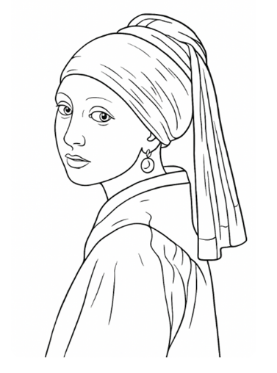
Picture example:
Contents list
Annibale Carracci, Man with a monkey
Annibale Carracci, Portrait of a woman holding a clock
Anthony van Dyck, Charles 1
Artemisia Gentileschi, Self-portrait as Saint Catherine of Alexandria
Bartolomé Esteban Murillo, Three boys playing dice
Diego Rodríguez de Silva y Velázquez, Infanta Margarita Teresa in a blue dress
Diego Rodríguez de Silva y Velázquez, The water seller of Seville
Diego Rodríguez de Silva y Velázquez, Equestrian portrait of Prince Balthasar Charles
Johannes Vermeer, Girl with a red hat
Johannes Vermeer, Girl with Pearl Earring
Johannes Vermeer, Mistress and maid
Johannes Vermeer, The astronomer
Johannes Vermeer, The geographer
Johannes Vermeer, The lacemaker
Johannes Vermeer, The Little Street
Michelangelo Merisi da Caravaggio, Boy bitten by a lizard
Michelangelo Merisi da Caravaggio, Narcissus
Peter Paul Rubens, Equestrian portrait of the Duke of Lerma
Rembrandt van Rijn, A young man and a girl playing cards
Rembrandt van Rijn, Girl in the window
Rembrandt van Rijn, Portrait of a lady with a lap dog
Rembrandt van Rijn, Rembrandt as a shepherd
Rembrandt van Rijn, The prodigal son
Rembrandt van Rijn, Young woman trying on earrings
Arts Award Initiative Ltd

