Colour Your Way Through the World of Abstract Art!
Get ready to explore a world of bold shapes, swirling lines, and wild imagination – all inspired by the amazing styles of abstract artists such as Kandinsky, Braque, and Miro.

This creative colouring book transforms real abstract artworks into line drawings to colour – perfect for artists of all ages.

If you love making patterns or experimenting with colour, you’ll enjoy every page that invites you to play and create freely.

Please visit www.artsawardinitiative.co.uk for information about all our books.
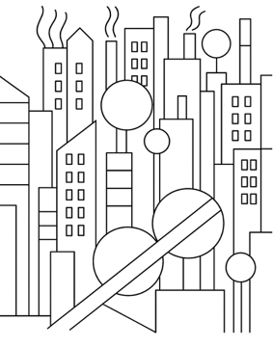
Page example:

Contents list
Arshile Gorky, Untitled
František Kupka, Le Jaillissement II
Georges Braque, Houses at Estaque
Georges Braque, Violin and candlestick
Joan Miró, The garden
Joan Miró, The singing fish
Joan Miró, Woman Bird Star, homage to Picasso
Josef Albers, The interaction of colour
Josef Albers, White line squares
Joseph Fernand Henri Léger, from the series Contrast of forms
Joseph Fernand Henri Léger, The builders
Joseph Fernand Henri Léger, The City
Kazimir Malevich, Marpha and Van’ka
Kazimir Malevich, Morning in the village after snowstorm
Kazimir Malevich, Supremus 56
László Moholy-Nagy, Bridges
Mark Rothko, Fantasyothko, Primaeval landscape
Theo van Doesburg, Geometriche Komposition
Theo van Doesburg, Heroic movement
Wassily Kandinsky, 13 Rectangles
Wassily Kandinsky, Abstract Cubinism in pinks and blues
Wassily Kandinsky, Composition 1930
Wassily Kandinsky, Horn shape
Wassily Kandinsky, Swinging

