My Colouring Book: Food shown in famous paintings
Feast your eyes on a delicious slice of art history!
From market stalls bursting with fruit to intimate family dinners, to glorious arrays of fruit and veg, this tasty colouring book invites all artists to explore famous artworks that celebrate food in all its forms.
Discover how great painters captured loaves, lemons, and quiet dinners, then bring them to life with colour!
Relaxing and educational.
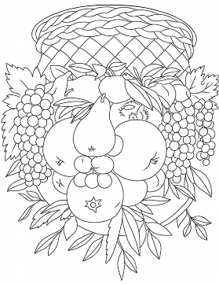
For more information about our books, see: www.artsawardinitiative.co.uk
Page example:

Contents
Apple harvest at Eragny, Camille Pissarro
The fruit basket, Giuseppe Arcimboldo
Café terrace at night, Van Gogh
Peeled lemons, Eliot Hodgkin
Brought to life, Eliot Hodgkin
Coupons required, Leonora Kathleen Green
Wendy’s Noah Verrier
Gulls’ eggs in a box, Eliot Hodgkin
Isabella and the pot of basil, William Holman Hunt
Mound of butter, Antoine Vollon
October, Eliot Hodgkin
Still life with figs and bread, Luis Melendez
Still life with flowers and fruit, Claude Monet
Supper at Emmaus, Jacopo Carucci
Taco Bell, Noah Verrier
The basket of apples, Paul Cezanne
Boy with a basket of fruit, Michelangelo Merisi da Caravaggio
The Milkmaid, Johannes Vermeer
The prayer before a meal, Jean Simeon Chardin
The water seller of Seville, Diego Velázquez
Vertumnus, Giuseppe Arcimboldo
White bread, James Rosenquist
White soup bowl, Anne Coster Vallayer
Boy Drinking, Michelangelo Merisi da Caravaggio
The Breakfast Table, John Singer Sargent

