Step into a magical garden of flowers and fairies
My Colouring Book: Flower Fairies is a beautifully illustrated colouring book filled with delicate fairy figures, intricate floral designs, and enchanting botanical details. Each page invites you to slow down, relax, and bring these magical scenes to life with colour.
Inspired by nature, fantasy, and classic botanical illustration, this book is perfect for colouring enthusiasts who enjoy elegant line art, flowing floral forms, and imaginative fairy artwork.
Whether you colour for relaxation, creativity, or mindful calm, Flower Fairies offers a soothing and rewarding colouring experience.
Inside this book, you’ll find:
- Enchanting flower fairies surrounded by detailed blooms
- Intricate floral designs
- Elegant line art suitable for pencils, pens, and markers
- Single-sided pages to help prevent bleed-through
- A calming, creative activity for teens and adults
Perfect as a gift or a personal escape, My Colouring Book: Flower Fairies is a gentle journey into a world of imagination, nature, and creativity.
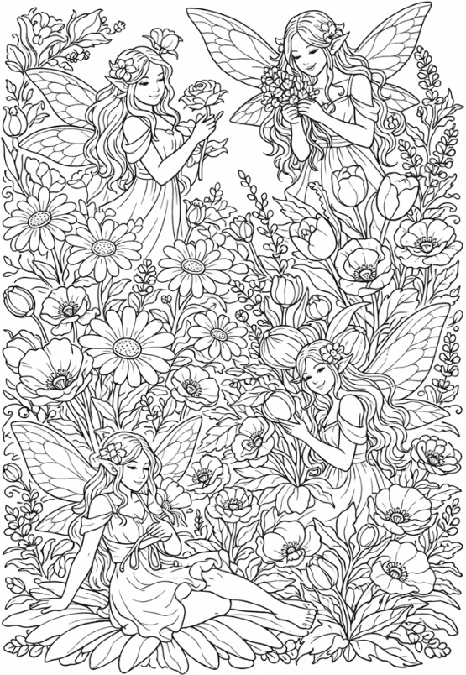
Please visit www.artsawardinitiative.co.uk for details about our other books
Page example:

