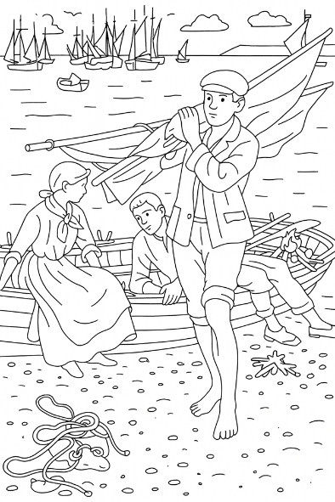
My Colouring Book: Colour the classics, from River to Sea, brings together a beautiful collection of rural landscapes inspired by great artworks from across art history.
Designed for all ages, this book is perfect for quiet creative time, art lessons, home education, mindfulness, or simply switching off from screens for a while.
Whether you’re an art lover, a nature lover, a history lover, a keen artist or young or old, you can explore landscapes in classic art through relaxing colouring, enjoy calm, screen-free creativity and learn about famous artists and their styles as you work.
See our other colouring books at www.artsawardinitiative.co.uk.
Page example:

Contents
Achille Vertunni, View across the lagoon
Alexander Nasmyth, A view of Tantallon Castle
Alfred Sisley, The path to the old ferry at By
Berthe Morisot, Beside a lake
Claude Monet, Impression, Sunrise
Claude Monet, Japanese Bridge
Claude Monet, Rocks at Belle-Île, Port-Domois
Claude Monet, The Thames below Westminster
Claude Monet, Water Lilies
David Hockney, A Bigger Splash
Emile Bernard, Vue de Port de Vathy Samos
Fidelia Bridges, January
Gustave Caillebotte, Sailboats in Argenteuil
Gustave Caillebotte, Sunflowers on the banks of the Seine
Gustave Caillebotte, The Canoes
Henry Scott Tuke, Return from fishing
Huang Junbi, Under pine tree watching waterfall
James Gale Tyler, The USF Constitution at sea
Joaquin Sorolla, Walk on the beach
Katsushika Hokusai, The waterfall where Yoshitsune washed his horse
Katsushika Hokusai, Waves
László Moholy-Nagy, Bridges
Leon Bonnat, Roman girl at a fountain
Nikolai Bogdanov-Belsky, Mid-day fishing
Ohara Koson, Mandarin Ducks
Salvador Dali, Swans Reflecting Elephants
Thomas Moran, Waterfall in Yosemite

