My Colouring Book: Beautiful Britain is a celebration of the landscapes of the United Kingdom. From windswept coastlines and peaceful lakes to rolling hills, historic bridges and timeless countryside, this collection of 50 iconic scenes invites you to reconnect with the places that feel like home.
Each page captures the spirit of Britain, taking you on a journey across England, Scotland, Wales and Northern Ireland; its quiet beauty, its rugged drama, its centuries of history written into stone, field and shoreline
It is suitable for all ages, as perfect for a child discovering Britain’s beauty for the first time as it is for an adult seeking calm, nostalgia and mindful creativity.
Please visit www.artsawardinitiative.co.uk to see our other books

Page examples:
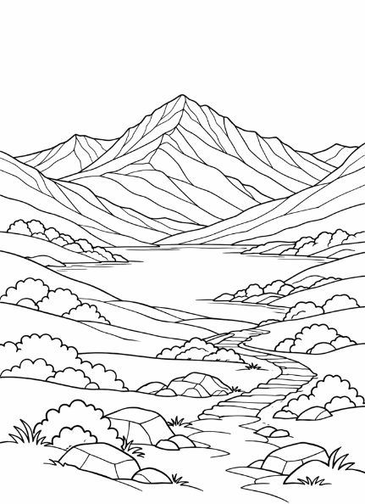 Snowdon

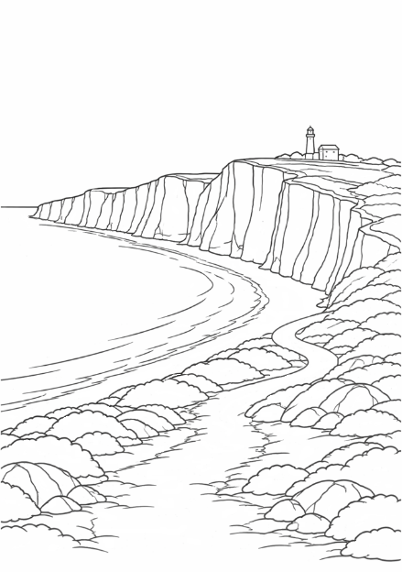 White Cliffs of Dover

