My Colouring Book: Animals from Famous Paintings brings together a beautiful collection of animal images inspired by great artworks from across art history. From bold, modern shapes to majestic stags, graceful horses and tiny songbirds, each page invites you to slow down, notice the details and add your own colours.
Designed for both adults and children, this book is perfect for quiet creative time, art lessons, home education, mindfulness, or simply switching off from screens for a while.
The artwork is carefully redrawn as clean line illustrations, ready for coloured pencils, crayons, or fine liners.
Whether you’re an art lover, an animal lover, a history lover, a keen artist or young or old, you can explore animals in classic art through relaxing colouring, enjoy calm, screen-free creativity and learn about famous artists and their styles as you work.
See our other colouring books at www.artsawardinitiative.co.uk.

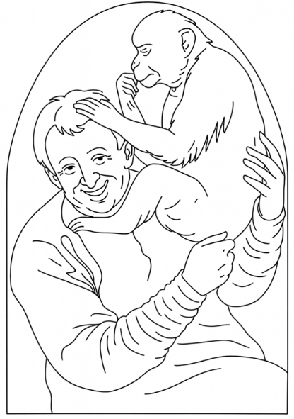
Page example:

Contents
Albert Durer, The hare
Briton Riviere, Compulsory Education
Henri de Toulouse-Lautrec, The cat
Franz Marc, The Blue Horse
Carel Fabritius, The Goldfinch
Franze Marc, Deer in the Snow
Melchior d’Hondecoeter, The poultry yard
Franz Marc, The white dog
Sir Peter Paul Rubens, Equestrian portrait of the Duke of Lerma
Ancient Egyptian (unknown) Cat
Franz Marc, Four deer
Joan Miró, The singing fish
Franz Marc, The Yellow Cow
Annibale Carracci Man with a monkey
George Stubbs, Whistlejacket
Hans Thoma, Wondrous birds
Henri Rousseau, The equatorial jungle
Jacques-Laurent Agasse The Nubian Giraffe
Charles Burton Barber, A little girl and her sheltie
Henri Rousseau, Le chat Tigre
Edwin Landseer, The Monarch of the Glen
Tobias Stranover, Peacock, Hen, And Male Pheasant In a Landscape
Suzanne Valadon, Bouquet and a cat
Charley Harper, Red and fed

