My Third Book of Nursery Rhymes
A Read-and-Colour Adventure!

Step back into the enchanting world of rhythm, rhyme, and imagination with My Third Book of Nursery Rhymes — the perfect companion to the original favourite!

This beautifully designed colouring book features 12 more beloved traditional rhymes, with Hot Cross Buns, London Bridge is falling down, Ring a ring a roses, and more favourites. Each rhyme is paired with a detailed, black-line illustration on a crisp white background, ready for children to colour and bring to life.

As children read, rhyme, and colour their way through each page, they’ll enjoy a creative experience that is truly their own.
Perfect for ages 3–11, this book supports:
- Creativity and self-expression
- Early reading and language rhythm
- Fine motor skill development

Whether at home, in the classroom, or on the move, My Third Book of Nursery Rhymes makes storytelling interactive, artistic, and full of joy.
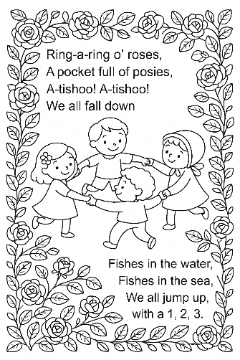
Page example
Contents:

Hot cross buns
I saw a ship a sailing
Incy Wincy spider
It’s raining, it’s pouring
London Bridge is falling down
Old King Cole
Old Mother Hubbard
Pat a cake
Pop goes the weasel
Ride a cock horse
Ring a ring a roses
Row your boat

