Step into a charming little gallery of childhood nostalgia with My Colouring Book: Toys, Teddies and Treasures from Classic Paintings.
This colouring book celebrates the playful from great works of art, beloved teddies, timeless dolls, rocking horses, and toy soldiers.
Each illustration is inspired by a classic painting, and presented as a clear, line drawing, designed for peaceful, relaxing, mindful colouring.
Perfect for art lovers, museum goers, and anyone who enjoys a gentle dose of nostalgia, this book offers a calm, creative escape and a fresh way to connect with art history.
A thoughtful gift for creative people, or a beautiful treat for yourself.
Please see our other books at: www.artsawardinitiative.co.uk
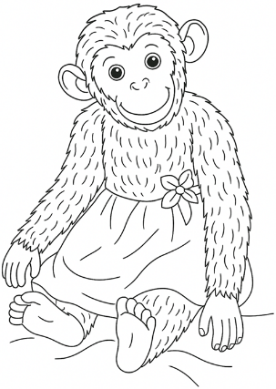
Page example:

Contents
Allan Ramsay, Prince William
Bartolomé Esteban Murillo, Three boys playing dice
Bernardus Johannes, The Fisherman's children
Boris Kustodiv, The toy monkey
Charles Bertrand d’Entraygues, The toy horse
Emil Kraus, Young girl with doll
Francisco de Goy, Jose Costa Y Bonnells
Gertrude Alice Kay, The bonfire, from Adventures in our street
John George Brown, A surprise party
Josef Danhauser, The little virtuosos
Karl Gottlieb Schweikart, Portrait of Dziecka
Mariya Molchanova, Childhood toys still life
Norman Hepple, Portrait of the artist's daughter
Oskar Laske, Weihnacht
Pablo Picasso, Child playing with a toy truck
Pablo Picasso, Girl with doll
Paul Klee, The red balloon
Paul van Somer, Portrait of a child with a rattle
Pierre-Auguste Renoir, Gabrielle and Jean
Pierre-Auguste Renoir, The swing
Pieter Bruegel the Elder, Children's games (detail)
Pieter Oyens, Portrait of Hendrik Waller at the age of 3
Rembrandt van Rijn, A young man and a girl playing cards
Unknown, Children playing in an Autumn courtyard (detail)
Unknown, Penny Toy, Hand-painted tin toy of a carousel, London Museum
Unknown, Penny toy, Hand-painted tin toy of a pram, London Museum
Unknown, Russian toys, Durham University

