My Own Book of Nursery Rhymes
A Read-and-Colour Adventure!
Step into a world of rhythm, rhyme, and creativity with My Own Book of Nursery Rhymes!
This delightful colouring book brings 12 traditional nursery rhymes to life, from Twinkle Twinkle Little Star to Humpty Dumpty and more.
Each page features beautifully illustrated scenes with bold black outlines on crisp white backgrounds, perfect for little hands to colour. Children can read along with the rhymes while using their imagination to fill the pictures with colour — making every page truly their own!
Perfect for ages 3–11, this book encourages:
- Creativity and self-expression
- Early reading and rhyme recognition
- Fine motor skill development
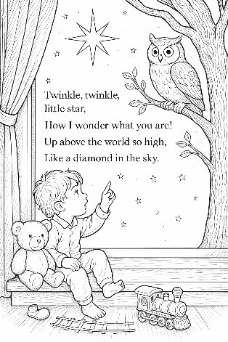
Whether it’s at home, in the classroom, or on the go, My Own Book of Nursery Rhymes is a magical way to blend story time and colouring fun in one joyful experience.
Page example
Contents:
1 2 3 4 5, Once I caught a fish alive
Baa, Baa, black sheep
Dr Foster
Goosey, Goosey Gander
Humpty Dumpty
Jack and Jill
Little Boy Blue
Little Jack Horner
Sing a song of sixpence
The Owl and the Pussy Cat
Twinkle, twinkle, little star
Wiggly Woo

