Colour Your Way Through the World of the Post-Impressionists!
Step into a vibrant world of bold colours, swirling skies and striking shapes, all inspired by the famous artists of the Post Impressionist era.
This exciting colouring book turns real Post-Impressionist masterpieces into clear line drawings, perfect for artists of all ages to enjoy.
Suitable for all ages, as a gift, or as a treat for yourself.
For a full contents list, please see our website: www.artsawardinitiative.co.uk

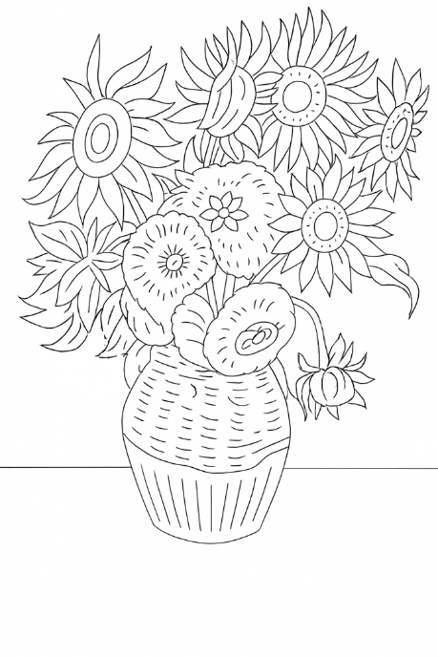
Page example:
Contents list
Émile Henri Bernard, Époque de Pont Aven
Émile Henri Bernard, La Moisson
Émile Henri Bernard, Les Roses
Émile Henri Bernard, Paysage avec deux Bretonnes et vache
Émile Henri Bernard, Vue des Toits
Georges Seurat, A man leaning on a parapet
Georges Seurat, Morning walk
Georges Seurat. The circus
Henri de Toulouse-Lautrec, Portrait of Vincent van Gogh
Henri de Toulouse-Lautrec, Side saddle
Henri de Toulouse-Lautrec, The cat
Henri Rousseau, Boy on the Rocks
Henri Rousseau, The equatorial jungle
Paul Cézanne, A view of Gardanne
Paul Cézanne, L’estaque
Paul Gauguin, A walk in the park
Paul Gauguin, Blue trees
Paul Gauguin, Road in Tahiti
Suzanne Valadon, Bouquet and a cat
Suzanne Valadon, L’Eglise d’Erigny
Suzanne Valadon, Study of a cat
Vincent van Gogh, Café terrace at night
Vincent van Gogh, Head of a peasant woman with a white cap
Vincent van Gogh, Irises
Vincent van Gogh, Sunflowers
Arts Award Initiative Ltd

