Colour Your Way Through the World of the Impressionists
Step into a dreamy world of sunlight, gardens and dancers – all inspired by the famous brushstrokes of artists like Monet, Renoir, and Degas.
Inside you'll find:
26 scenes inspired by real Impressionist masterpieces
A4 pages with clean black outlines inspired by original paintings by the old masters
A fun way to learn about famous artists and their beautiful world
Suitable for all ages, as a gift, or as a treat for yourself.
For a full contents list, please see our website: www.artsawardinitiative.co.uk

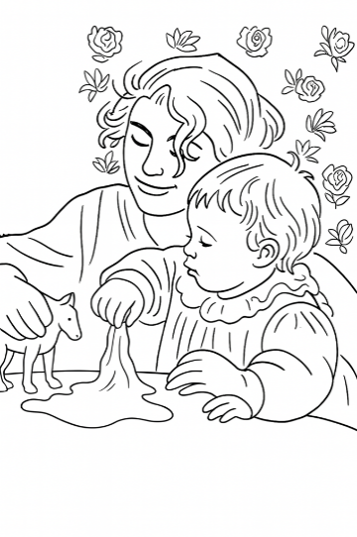
Picture example:
Contents list
Berthe Morisot, Beside a lake
Berthe Morisot, Femme et enfant au balcon
Berthe Morisot, Fillette portant un panier
Camille Pissarro, Fox Hill, Upper Norwood
Camille Pissarro, Late afternoon in our meadow
Camille Pissarro, The Boulevard Montmartre at night
Claude Monet, Monet’s garden
Claude Monet, The Thames below Westminster
Claude Monet, Woman with Parasol
Edgar Degas, At the stables
Edgar Degas, Dancer
Edgar Degas, The ballet class
Gustave Caillebotte, Chrysanthemum, Garden At Petit Gennevilliers
Gustave Caillebotte, Sailboats in Argenteuil
Gustave Caillebotte, Sunflowers on the banks of the Seine
Gustave Caillebotte, The Canoes
Gustave Caillebotte, The Painter under his parasol
Mary Cassatt, The Child's Bath
Mary Cassatt, Woman with needlework
Mary Cassatt, Young mother sewing
Paul Cezanne, Turning Road at Montgeroult
Pierre-Auguste Renoir, Dance at Bougival Art
Pierre-Auguste Renoir, Femme au chat
Pierre-Auguste Renoir, Gabrielle and Jean
Pierre-Auguste Renoir, Girls at the piano
Pierre-Auguste Renoir, The Swing

