Inspired by the Expressionists
Colour Your Way Through the World of the Expressionists!
Step into a world of vibrant emotions, dramatic shapes, and powerful brushstrokes – inspired by the expressive art of masters like Edvard Munch, Franz Marc, and August Macke.
This exciting colouring book turns bold Expressionist masterpieces into simple, striking line drawings – perfect for creative minds and young artists. If you're drawn to wild colours or want to explore big feelings through art, each page invites you to make your mark.
Whether you’re a budding artist or history explorer, our ‘Colouring the Classics’ and our ‘Inspired by’ books bring the wonders of the art gallery to your fingertips—one colour at a time!
Inside you'll find:
26 dynamic scenes inspired by real Expressionist artworks
A4 pages with crisp, clear outlines – no shading, no fuss
A powerful way to explore emotions, movement, and the magic of Expressionism
Please see www.artsawardinitItaive.co.uk to see our other books
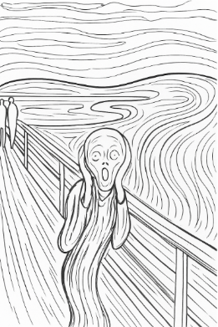
Page example:
Contents list
August Robert Ludwig Macke, Fashion window
August Robert Ludwig Macke, Russian ballet
August Robert Ludwig Macke, St George
August Robert Ludwig Macke, The Hat Shop
August Robert Ludwig Macke, Tightrope walker
August Robert Ludwig Macke, Walking in the park
Edvard Munch, Anxiety
Edvard Munch, The Scream
Ernst Ludwig Kirchner, Berlin Street Scene
Ernst Ludwig Kirchner, Street, Berlin
Franz Marc, Blue Horse
Franz Marc, Deer
Franz Marc, Deer
Franz Marc, Deer in the Snow
Franz Marc, Four foxes
Franz Marc, Sheep
Franz Marc, The white dog
Franz Marc, The Yellow Cow
Henri Emile Benoit Matisse, The Snail
Henri Emile Benoit Matisse, Woman with a Hat
Karl Schmidt-Rottluff, Sea snails
Karl Schmidt-Rottluff, Two women
Maurice de Vlaminck, Forest with red trees
Oskar Kokoschka, From The Dreaming Boys
Raoul Dufy, The White Sail
Arts Award Initiative Ltd

