History of Art: The First Artists, introduces the foundations of art history in a simple, engaging way, encouraging young artists to explore the earliest creative cultures and learn how people used art to tell stories, decorate objects, record their lives and honour their leaders, their gods, and their heroes.

Inside the book, you will find:
- An introduction to the periods covered,
- Simple educational introductions to each culture and the art forms to be explored,
- Colouring pages,
- Stories with illustrations to colour,
- Activity worksheets to support young artists who want to try new crafts

The book is perfect for all children aged 4–10, to use either for fun, or to support learning.

To see further details about this book and our other books, and see page examples from them, please visit: www.artsawardinitiative.co.uk

Page examples:
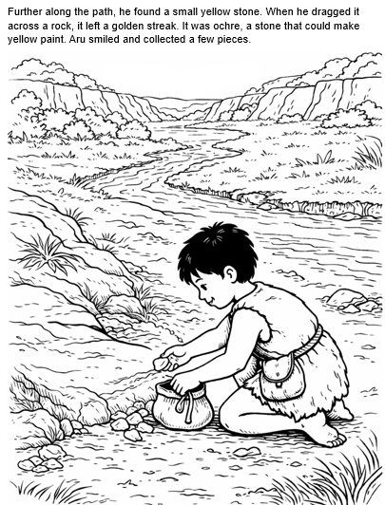 An illustrated story to colour
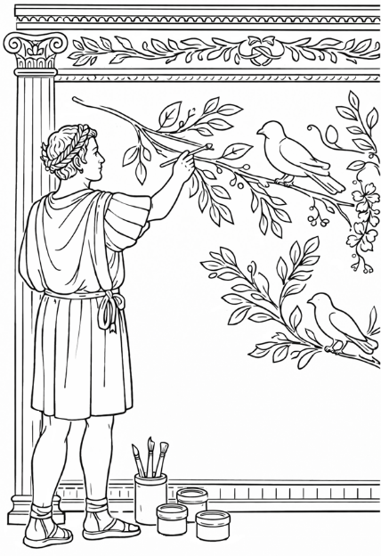Colouring page: A Roman Fresco
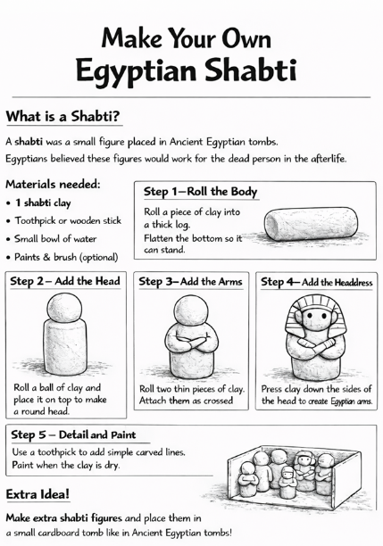Worksheet

