Discover the Wonders of History!
Ancient Civilisations: Book 3 – Voices across time is the perfect first step into the past for curious young minds aged 5 to 11.
Travel back thousands of years and explore the people who built the first Cultural Empires of the Ancient World, and the people who lived in them. Explore: Ancient Inuit, and Aboriginals, along with the Maya, the Neolithic British, the Polynesian Navigators and more.
For each civilisation, you’ll find:
- A fact sheet about the civilisation, full of fascinating information
- A colouring page showing life there and/or landmarks
- A fact sheet about an impressive warrior or religious leader
- A colouring page of the leader, or a sacred artefact, to bring the past to life
- A short, child-friendly story about a young person’s day in this ancient world
- Plus another colouring page inspired by the child’s daily life!
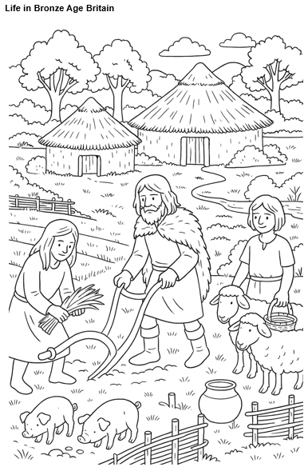
Designed to spark creativity and curiosity, this Read and Colour history book helps children connect with the people, places, and ideas that shaped our shared history — all while having fun!
Page example:
Civilisations covered in this book:
Bronze Age Britain
The Maya
Aboriginal Australians
Ancient Inuit
Ancient Japan
The Polynesian Navigators
Nok Culture
Ancient Armenia and the Kingdom of Urartu

