Ancient Civilisations: Book 2 – Warriors, Rulers and Empires is the perfect first step into the past for curious young minds aged 5 to 11.
Travel back thousands of years and explore the people who built the first Cultural Empires of the Ancient World, and the people who lived in them.
For each civilisation, you’ll find:
- A fact sheet about the civilisation, full of fascinating information
- A colouring page showing life there and/or landmarks
- A fact sheet of an impressive warrior or religious leader
- A colouring page of the leader, or a sacred artefact, to bring the past to life
- A short, child-friendly story about a young person’s day in the ancient world
- Plus another colouring page inspired by the child’s daily life!
Designed to spark creativity and curiosity, this Read and Colour history book helps children connect with the people, places, and ideas that shaped our shared history — all while having fun!
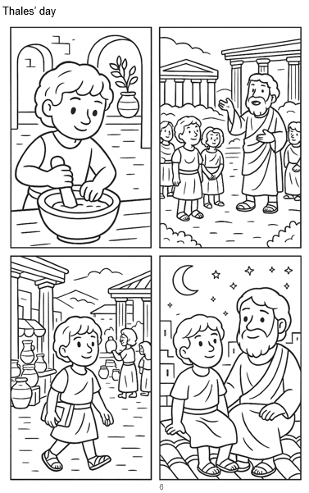
Page example:
Civilisations covered in this book:
Ancient Greece
The Persian Empire
Ancient Rome
Carthage
Celts
Mississippian Culture
Scythian Steppe Culture
The Aksumite Empire

