Ancient Civilisations: Book 1 – Early World Cultures is the perfect first step into the past for curious young minds aged 4-10.
Travel back thousands of years and explore the first cities, rulers, and belief systems from across the ancient world.
For each civilisation, you’ll find:
• A fact sheet about the civilisation, full of fascinating information
• A colouring page showing life there and/or landmarks
• A fact sheet of an impressive leader or religious leaders
• A colouring page of the leader, or a sacred artefact, to bring the past to life
• A short, child-friendly story about a young person’s day in the ancient world
• Plus another colouring page inspired by the child’s daily life!
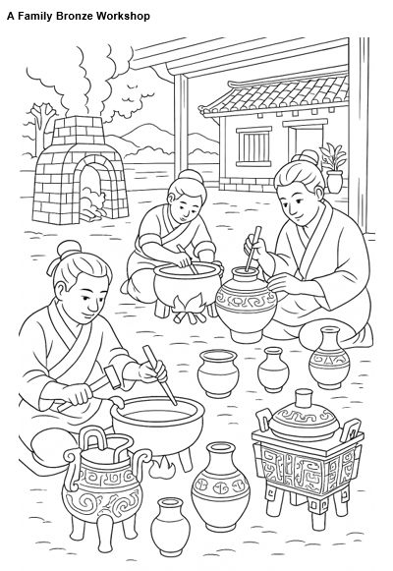
Designed to spark creativity and curiosity, this Read and Colour history book helps children connect with the people, places, and ideas that shaped our shared history — all while having fun!
Page example:
Civilisations covered in this book:
Mesopotamia
Ancient Egypt
The Indus Valley
The Shang Dynasty
Mycenaean Greece
The Kingdom of Kush
Olmec
Gojoseon
Ban Chiang
The Nazca

