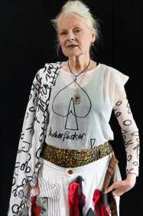
Vivienne Westwood

🧵 What Did She Create?
Vivienne Westwood was a British fashion designer who brought punk style into high fashion and made New Wave mainstream.
She designed clothes, shoes, jewellery, and accessories that were bold, rebellious, and often inspired by history and politics.
In 2022, Sky Arts ranked her the 4th most influential artist in Britain of the last 50 years

She was a Taoist and a vegetarian

👧 Childhood Facts
- Born: Vivienne Isabel Swire on April 8, 1941, in Glossop, Derbyshire, England.
- Family: Her father was a cobbler, and her mother worked in a cotton mill.
- Moved to London: At age 17, her family relocated to Harrow, Greater London.
- Early Work: She worked in a factory and later trained as a primary school teacher.

🎓 Arts Education
- Harrow School of Art: She briefly attended this school but left after one term.
- Jewellery Making: She created her own jewellery and sold it at a stall on Portobello Road.
- Teaching: Studied at a teacher-training college and became a primary-school teacher.
- Self-Taught Designer: She taught herself fashion design by deconstructing old clothes

🧵 Notable Designs

Orb Logo: Her signature logo combines royal and planetary symbols.
Westwood called herself the ‘Queen of Fashion’, so her logo incorporates the royal orb and sceptre, with Saturns rings around it
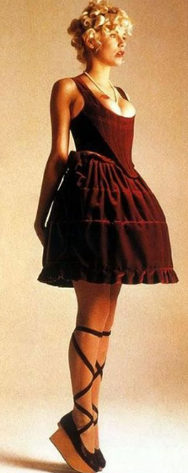
Mini-Crini (1985): A mini skirt inspired by Victorian crinolines.
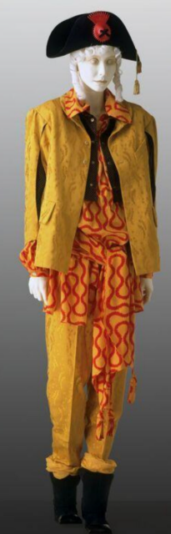
Pirate Collection (1981): Featured historical and romantic themes.
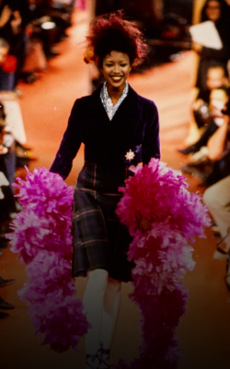
Anglomania (1993): Blended British and French fashion elements.

👗 Career Highlights
- Boutique "Let It Rock": In 1971, she opened a boutique with Malcolm McLaren at 430 King's Road, London.
- Punk Fashion: Her designs helped shape the punk movement in the 1970s.
- Iconic Collections: Known for collections like "Pirate" (1981) and "Anglomania" (1993).
- Honors: Appointed Dame Commander of the Order of the British Empire (DBE) in 2006 for services to fashion.

💬 Quotes
- "Buy less. Choose well. Make it last."
- "The best fashion accessory is a book."
- "Culture is necessary for human beings to evolve into better creatures."
Please see our Fashion Illustration guide for workshops

