Andy Warhol

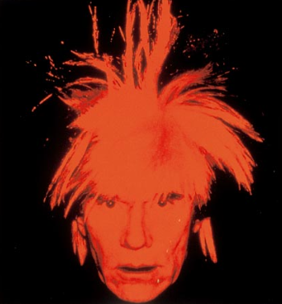
🖌️ What Did Andy Warhol Create?
Andy Warhol was a pop artist who made bright, colourful pictures of everyday things like soup cans, celebrities, and comic strips. He used a method called screen printing to repeat the same image over and over in different colours.

👶 Childhood
- Andy Warhol was born in 1928 in Pittsburgh, USA.
- His real name was Andrew Warhola.
- He was often sick as a child and spent lots of time drawing and listening to the radio.
- He loved to collect pictures of movie stars from magazines.

🎓 Education
- He studied commercial art at Carnegie Institute of Technology.
- He practised drawing shoes, people, and advertisements.
- He moved to New York City after college to become a commercial artist.
- He was very good at blending fine art with advertising.

🌟 Career
- Andy became famous for turning soup cans and celebrities into art!
- He opened a studio called The Factory, where artists and friends made art together.
- He made films, designed album covers, and even worked with fashion brands.
- Andy loved to make art with other people, including children and students.

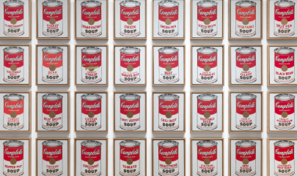
🖼️ Artwork
Campbell’s Soup Cans

Marilyn Diptych Grevy’s Zebra
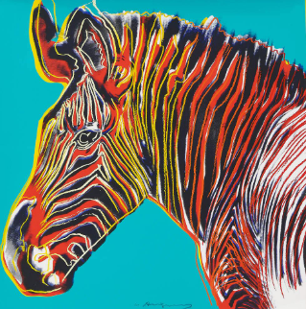
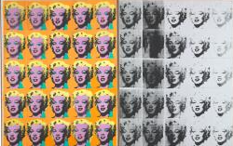

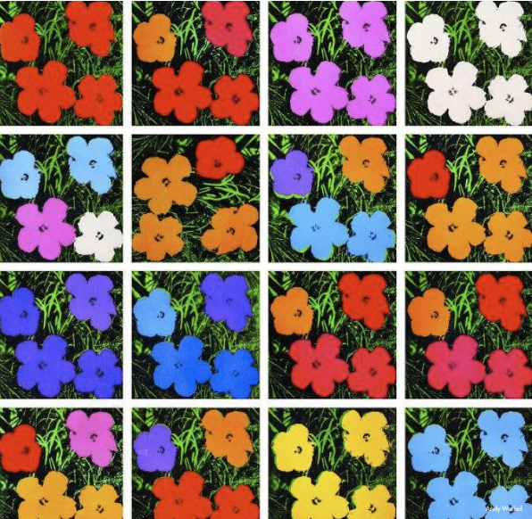
Flowers

💬 Quotes from Andy Warhol:
- “Everyone will be famous for 15 minutes.”
- “Art is what you can get away with.”
- “I just paint things I always thought were beautiful.”

