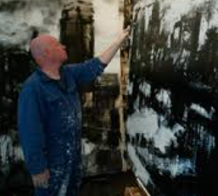
John Virtue

🖌️ What Does John Virtue Create?
John Virtue is a British artist known for his large, black-and-white landscape paintings. He uses only black ink and white paint because he believes colour is a distraction. His artworks often show cities and seas, mixing real places with imagination. He paints with strong lines and big brush strokes.

👶 Childhood
• He was born in 1947 in Accrington, Lancashire, England.
• He loved drawing from a young age.
• He won a painting prize as a teenager.
• The hills and towns near his home inspired his early art.

🎓 Education
• He studied at the Slade School of Fine Art in London.
• He had important art teachers who helped him grow.
• He later became a professor and taught other artists.
• He liked learning from old masters and modern painters.

💼 Career
• He worked as a postman while trying to become an artist.
• He became a full-time artist in the 1980s.
• He was chosen to be the National Gallery’s Associate Artist.
• His paintings have been shown in famous art galleries.

🖼️ Artwork
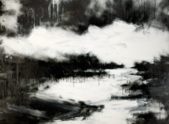
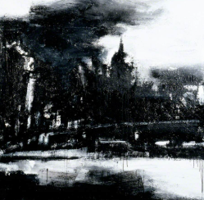
Landscape No. 664 – a bold view of London
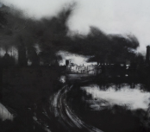
Landscape No. 707 – a swirling black-and-white cityscape

Landscape No. 567 – a powerful moody land painting
Houses on the Moor – a rare piece showing buildings
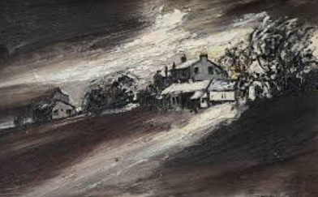

💬 Quotes from John Virtue
• "I use only black and white because colour is an unnecessary distraction."
• "My paintings are about the landscape I live in."
• "I try to make the invisible visible."

🎉 Fun Activities
- Make your own black and white painting using ink or paint

- Monochrome doesn’t necessarily mean you only work in black and white. You can work in tones of any colour. Try painting a green tree in a green garden, just use green tones.
- When John Virtue was Resident Artist at the National Gallery in London, he used to wake at dawn and go up on the roof to sketch views of London. He sketched and painted for two years to create his work. Here are some of his sketches.
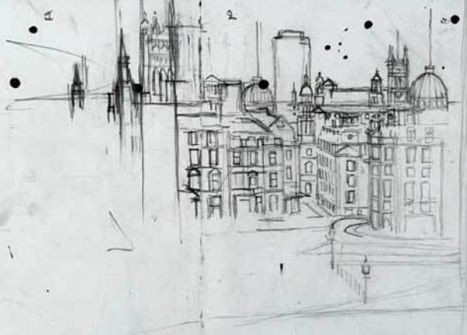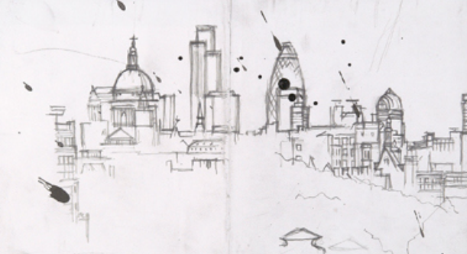
Go on a walk and sketch a place using only a black pen.

