Johannes Vermeer
🖌️ What Did Johannes Vermeer Create?
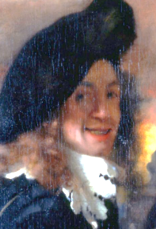
Johannes Vermeer painted quiet, peaceful scenes of everyday life in his home town. His art often showed women reading, playing music, or doing chores in softly lit rooms. He is famous for how he painted light, shadows, and texture, especially with the colours blue and yellow.

🧒 Childhood
- Johannes Vermeer was born in Delft, Netherlands in 1632.
- His father was an art dealer and owned an inn, so Vermeer saw art from a young age.
- He had a sister and grew up in a busy household full of people and ideas.
- His family wasn’t rich, but they supported his artistic interests.

🎓 Education
- No one knows for sure who taught him, but he likely trained with a local master painter.
- He became a member of the Guild of Saint Luke in Delft when he was around 21 years old.
- He studied other Dutch painters and learned how to mix beautiful colours like ultramarine and ochre.
- He may have used a camera obscura, a tool like a pinhole camera, to help plan his paintings.

👨‍🎨 Career
- He didn’t paint many works — only about 35 paintings survive today.
- His paintings weren’t widely known outside Delft during his lifetime.
- He often painted the same room in his house, changing the people and light.
- Vermeer became more famous after his death, when people realised how special his work was.

🖼️ Artworks
Girl with a Pearl Earring
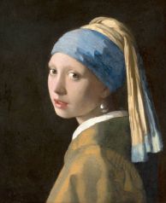
The Milkmaid
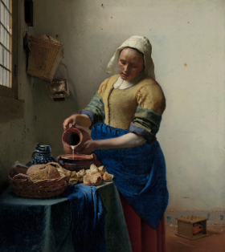
The Art of Painting
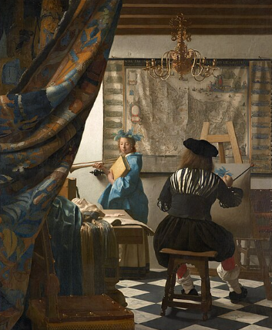

Woman Holding a Balance
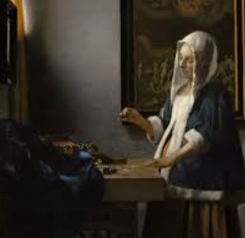
The Music Lesson
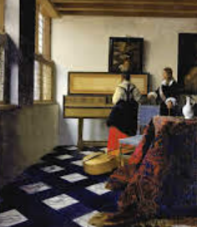

🗣️

Quotes about Johannes Vermeer
- “Vermeer’s paintings are like poems of light.” — Art Historian
- “In Vermeer’s world, time stands still.” — Art Critic
- “The light in his paintings is like magic.” — Artist’s Tribute

