Vatsal Kataria (VATKAT)

📸 What does he create?
Vatsal Kataria is a photographer who makes tiny scenes that look like real-life places!
He builds small models using cardboard, glue, clay, and paint, then takes photos that look like big dramatic landscapes.
His work turns miniatures into realistic, magical photos!

👦 Childhood
- Vatsal grew up in India, in the city of New Delhi.
- As a child, he loved making things with his hands.
- He didn’t have lots of expensive toys, so he used creative materials to build things himself.
- He was very curious and liked to imagine big worlds in small spaces.

🎓 Education
- He didn’t go to a traditional art school – he taught himself!
- He learned photography on his own using online videos and lots of practice.
- He studied how to use lighting and angles to make small things look real.
- He learned to build model sets out of anything – like Styrofoam, paper, mud, and paint!

💼 Career
- Vatsal became famous for showing how he makes his photos using behind-the-scenes pictures.
- His work has been featured in magazines and websites all over the world.
- He has worked on advertising projects using his tiny sets.

🖼️ Artworks, and how he makes them

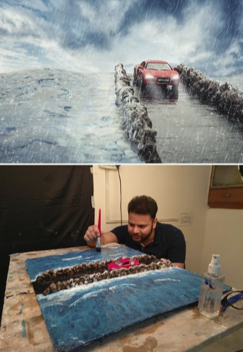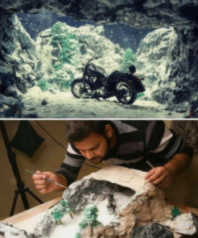

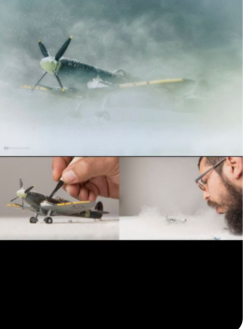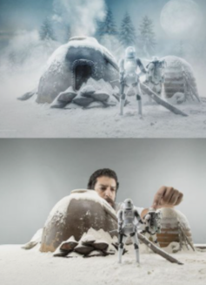

🎨 Activities
- Make Your Own Mini Scene! - Use cardboard, foil, paint, and paper to make a tiny mountain or house.
- Create a Tiny City! - Use bottle caps, matchboxes, and toy cars to build your own miniature town.
- Try Toy Photography! - Take pictures of your toys as if they’re in real adventures.
- Design a Diorama - Use a shoebox and turn it into a forest, desert, or outer space scene!
- Recreate this photograph
  - use modelling clay to make the rock
  - place it on a painted board
  - put a painting behind it
