👨‍🎨 Who is Vincent van Gogh?
Vincent van Gogh was a Dutch artist who painted with strong emotions, bright colours, and thick, swirling brushstrokes. He painted everyday things — like sunflowers, stars, and his bedroom — but made them feel alive and full of energy.
Van Gogh didn’t paint what things looked like exactly — he painted how they felt to him inside.

🖼️ What Will You Make?
You’ll paint a picture full of colour and movement, like a swirly sky, a field of sunflowers

🧰 You Will Need:
- A sheet of thick white paper or canvas (A4 or larger)
- Paints (acrylic or thick poster paint work best)
- Brushes — a thick one and a thin one
- A palette or plate for mixing
- A pencil (for a light sketch)
- A fork, sponge, or even your fingers (for texture — optional!)

Step 1: Choose Your Van Gogh-Inspired Scene
Pick one of these ideas:
- A starry night sky 🌌
- A field of sunflowers 🌻
- A colourful landscape with hills and trees 🌳

Step 2: Lightly Sketch the Main Shapes
- Use a pencil to gently draw the main parts of your picture:
  - The hills, flowers, stars.
- Keep the shapes simple — you’ll add excitement with paint!

Step 3: Choose Bright Van Gogh Colours
Van Gogh used bold colours like:
- Yellow 💛
- Blue 💙
- Orange 🧡
- Green 💚
- Red ❤️
- Purple 💜
💡 Tip: Don’t try to make colours look real — Van Gogh painted with feeling, not accuracy!

Step 4: Add the Background with Swirling Strokes
- Start by painting the sky or background.
- Use short, quick strokes — move your brush like you’re making dashes or swirls.
- For a night sky, try using blue, purple, and white with swirling stars.

Step 5: Paint the Main Shapes with Texture
- Use thick paint to fill in your flowers, face, or hills.
- Use a fork, sponge, or the end of your brush to make fun textures!
- Try painting in the same direction as the shape — like round strokes for a face, or wavy strokes for fields.

Step 6: Add Bold Details
- Outline with your brush or add more colour strokes to make your shapes stand out.
- Don’t blend too much — Van Gogh’s art had visible brushstrokes and lots of layers.

Step 7: Final Touches
- Add white or yellow dots to your sky for stars.
- Add extra dabs and swirls to show wind, movement, or sunshine.
- Stand back and see where it needs more energy or colour!

🎨 More Van Gogh Art ideas!
  - Can you sketch your own bedroom in the style of “Bedroom at Arles”?
Here are some examples:
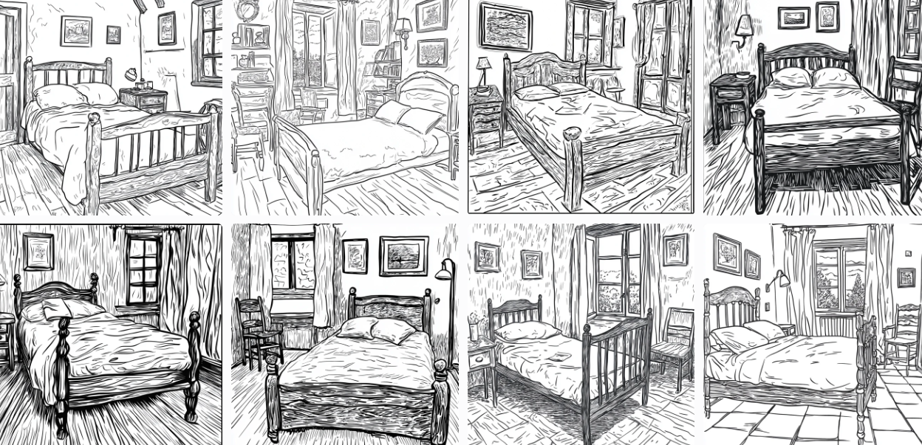
How would you colour your picture?

  - Try creating a bold self-portrait — using thick lines and vivid colours just like Van Gogh!

