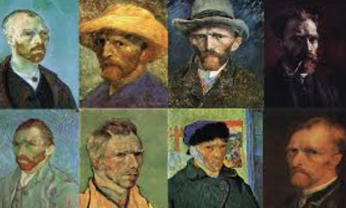
Have you ever seen a painting with swirly stars, bright yellow sunflowers, or a colourful field? If so, you might have seen a masterpiece by Vincent Van Gogh—one of the most famous artists in the world!

Who was Van Gogh?
👨 Name: Vincent Van Gogh
📅 Born: March 30, 1853, Died 29 July 1890
🌍 From: The Netherlands
🖌️ Made Over: 2,100 artworks!

 Education: Royal Academy of Fine Arts, Brussels, and the Royal Academy of Fine Arts, Antwerp
🎨 Painting style: Post-Impressionist
 Family: Van Gogh was the child of a Dutch Protestant preacher Theodorus van Gogh and Anna Carbentus, and he grew up in a peaceful family with two brothers and three sisters.
 Work: He started work as an Art dealer. He was very quiet and thoughtful by nature, and he grew depressed with this life. He had one brother, Theodorus who encouraged him to paint, and helped him a lot with money when his paintings didn’t sell.

Fun Van Gogh Facts! 🤩
🔹 He painted over 900 paintings in just 10 years! That’s almost two paintings a week!
🔹 He only sold one painting while he was alive – Red Vineyards near Arles
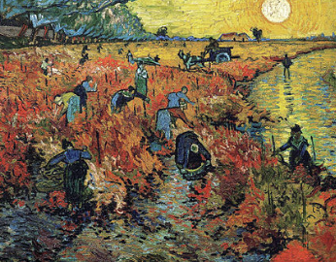
🔹 Now, his paintings are worth millions!
🔹 He loved nature and painted fields, trees, and flowers.
🔹 He used thick brushstrokes to make his paintings feel alive.

His Most Famous Paintings 🎨
✨ Starry Night – A sky full of twinkling stars and swirls
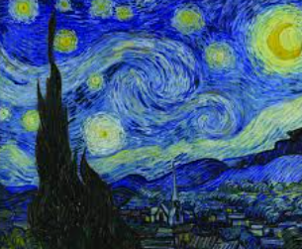
🌻 Sunflowers – A vase full of bright yellow flowers
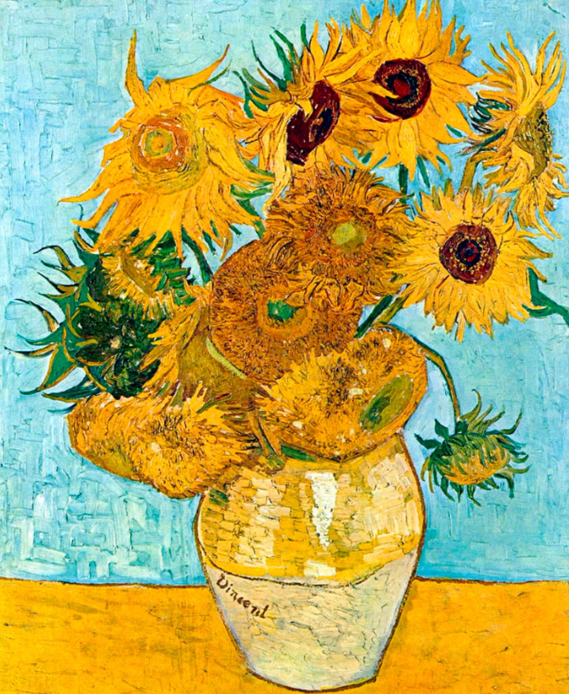
🏡 Bedroom at Arles – in his cozy home in France
