Joseph Mallord William Turner

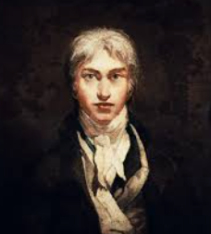
🖼️ What Did Turner Create?
Turner was a British artist who painted landscapes, seascapes, and dramatic skies using light, colour, and emotion. He is best known for his romantic and atmospheric paintings that often show storms, sunlight, and boats at sea.

👦 Childhood
- He was born in London in 1775.
- His father was a barber and wig-maker.
- He began drawing at a young age, especially when sent to stay with relatives in the countryside.
- His mother struggled with mental illness, and Turner often lived away from home.

🎓 Education
- He joined the Royal Academy of Arts at just 14 years old.
- He studied architecture and classical art as part of his training.
- He practised by copying famous paintings and sketching from nature.
- He showed his first work at the Royal Academy when he was only 15!

🎨 Career
- He became known as the “painter of light” because of the way he used colour and sunshine.
- He travelled around Britain and Europe, sketching mountains, lakes, and coastlines.
- Turner experimented with watercolour, oil paints, and unusual techniques.
- He left over 30,000 artworks to the nation when he died!

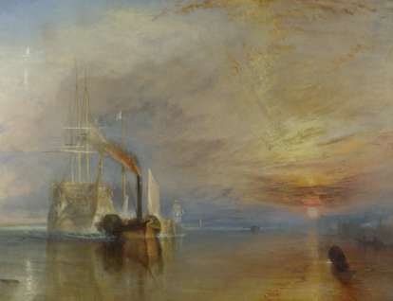
🖌️ Artworks
The Fighting Temeraire

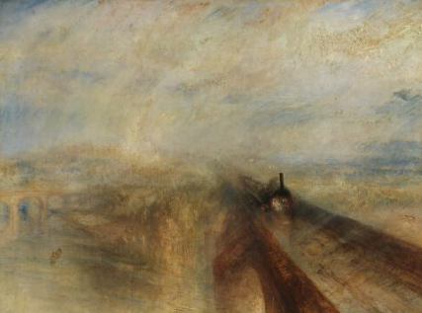
Rain, Steam and Speed

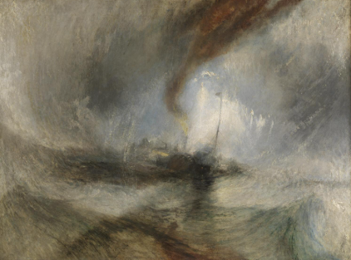
Snow Storm: Steam

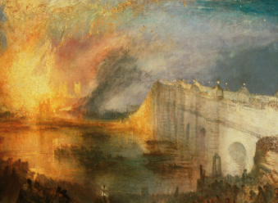
The Burning of the Houses of Lords and Commons

💬 Quotes from Turner
- “Light is therefore colour.”
- “I know of no genius but the genius of hard work.”
- “The Sun is God.”

