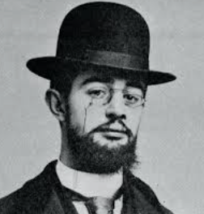
Henri de Toulouse-Lautrec
Famous for: Colourful posters, paintings of dancers, singers, and life in Paris.

🧒 Childhood
- Henri was born in France in 1864 to a noble family.
- As a child, he had fragile bones and broke both legs, which didn’t heal properly.
- Because of his condition, he didn’t grow very tall and used a cane.
- He loved to draw animals and people from a young age.

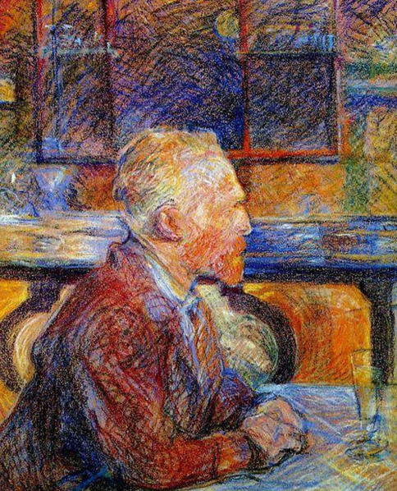
🎓 Education
- Henri took drawing lessons as a teenager to improve his skills.
- In 1882, he studied at the Atelier of Léon Bonnat in Paris.
- When that closed, he joined the Studio of Fernand Cormon, where he learned to draw from real life.
- At Cormon’s studio, he met other young artists like Émile Bernard and Vincent van Gogh. This is his painting of van Gogh.

🎭 Career
- Henri became known for painting and drawing life in Montmartre — a busy, fun part of Paris.
- He created posters of famous performers like dancers at the Moulin Rouge. He made most of his income from these posters
- His style used bright colours, bold lines, and captured movement.
- Though he died young, his artwork became very famous and is still loved today.

🎨 Art

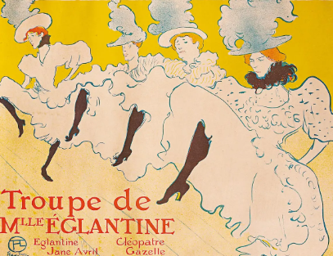
He was most famous for the posters he created of dancing girls. The "La Troupe de Mademoiselle Églantine" poster by Henri de Toulouse-Lautrec advertised a London performance at the Palace Theatre of Varieties in 1896. It was designed to promote the appearance of the Troupe of Mademoiselle Églantine, a French can-can dance troupe.
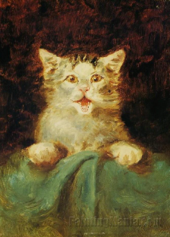
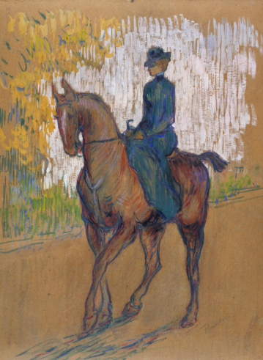

Side-saddle The cat

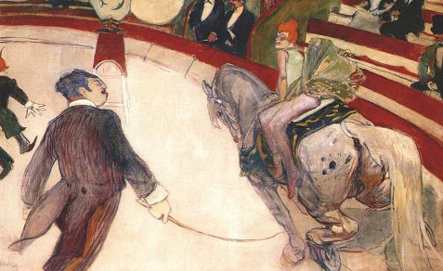

Equestrienne (At the Cirque Fernando)

💬 Quotes from Toulouse-Lautrec
- “I paint things as they are. I don’t comment.”
- “I have tried to do what is true and not ideal.”
- “A professional model is like a stuffed owl. These girls are alive.”

