Step-by-Step: Create a simple Sisley-inspired river landscape

Sisley painted in the Impressionist style, which meant:
- Short, quick brushstrokes to show movement and light
- Soft, natural colours rather than bold outlines
- He often painted "en plein air" (outdoors), using portable oil paints to capture real-life light and weather effects
Oil paints were ideal for this because they blend well, dry slowly, and allow for layering — perfect for showing shimmering water, cloudy skies, and leafy trees!

✏️ Step 1: Draw the River
Sketch a river curving through the middle of your page from the bottom to the top.
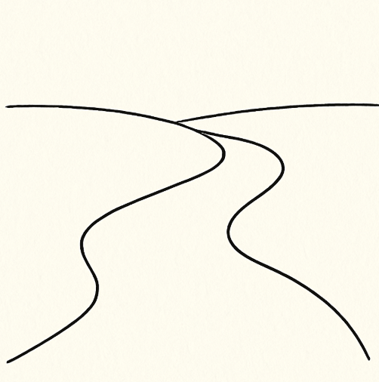

🌳 Step 2: Add Nature
Pencil in some trees and bushes along both sides of the river. Try making each tree different!
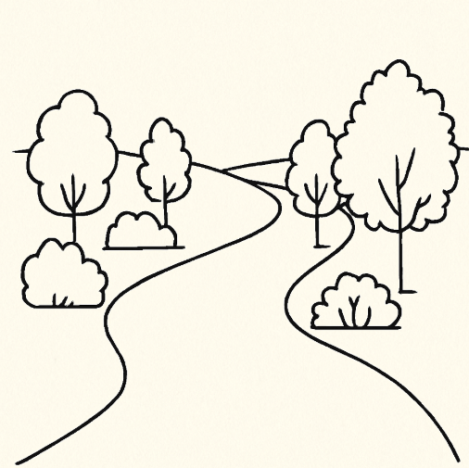

🌥️ Step 3: Light Sky
Use soft strokes of blue, white, and pink for a bright sky with light clouds.
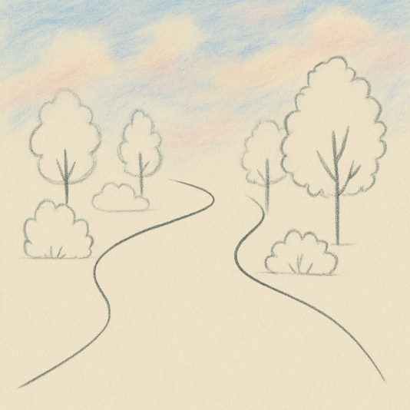.

🍃 Step 4: Colour the Trees and Grass
Now it's time to bring the landscape to life! Use greens, yellows, and soft browns to colour the trees, bushes, and grassy banks. Use small dabs or strokes to show leaves and textures.
- Trees: Use light and dark green to add variety to the leaves
- Grass: Blend yellow-green and soft blue-green for a natural look
- Bushes: Try using short, curved strokes to build up texture
🖌️ Tip: Like Sisley, keep your colours soft and natural, and don’t worry about staying perfectly inside the lines — Impressionists wanted to show feeling, not exactness!
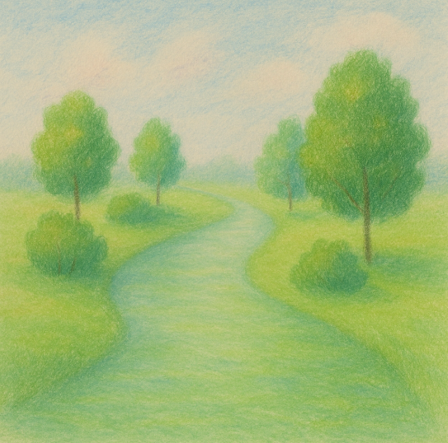

🖼️ Step 5: Reflections in the Water
Add reflections of trees and sky in the river using wavy lines of muted colours.
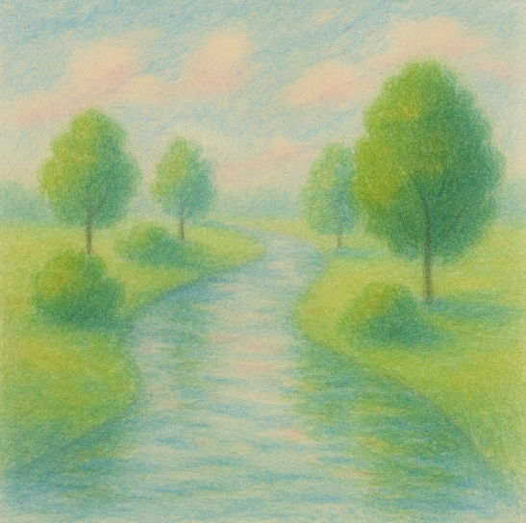

🎨 Step 6: Final Touches
Add a small bridge or cottage in the background. Keep your colours gentle and light.
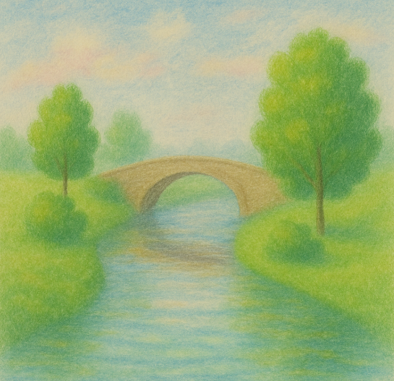

🌟 Additional Art Ideas
- Paint your local river or park like Sisley would — try working outdoors!
- Create a seasonal version: paint the same river in autumn, spring, or winter.
- Make a mini gallery: paint three small square landscapes and hang them side by side.
- Try painting with only 4 colours to explore light and shade, like the Impressionists!

