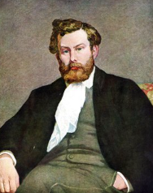
What Did Alfred Sisley Create?

Alfred Sisley was a landscape painter who loved painting outdoors. He captured peaceful rivers, trees, skies, and countryside scenes using soft colours and light brushstrokes. Sisley was part of the Impressionist movement, just like Monet and Renoir!

👶 Childhood
- Alfred Sisley was born in Paris, France, in 1839.
- His parents were from England, so he was actually British!
- His father ran a successful business selling silk.
- Alfred loved nature from a young age and liked walking in the countryside.

🎓 Education
- When he was 18, Sisley moved to London to study business — but he didn’t enjoy it!
- He returned to Paris and joined the École des Beaux-Arts (School of Fine Arts).
- There, he studied painting under Charles Gleyre.
- He met future famous artists there, like Claude Monet and Pierre-Auguste Renoir.

🧑‍🎨 Career
- Sisley painted outdoors, which was unusual at the time!
- He mostly painted landscapes, especially of rivers and bridges.
- He took part in the first Impressionist exhibition in 1874.
- He liked to work plein aire, which means outside in the open air, most of his work was created on site.
- Even though he didn’t become rich, today his work is celebrated around the world.

🎨Art

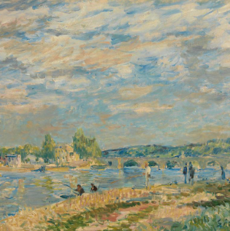
The Bridge at Sèvres

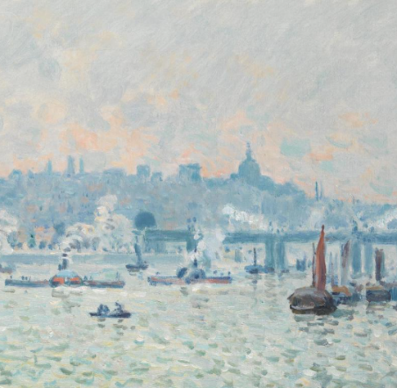
View of the Thames: Charing Cross Bridge

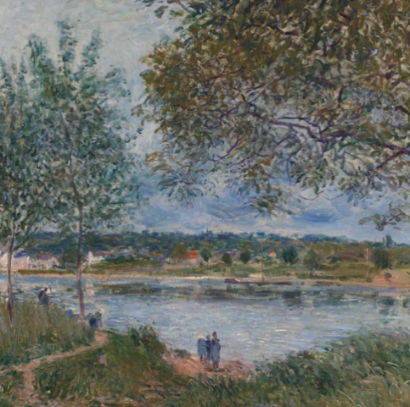

The Path to the Old Ferry at By

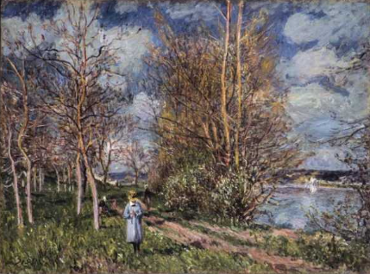

The Small Meadows in Spring

💬 Quotes from Alfred Sisley
“Every picture shows a spot with which the artist has fallen in love.”
“The animation of the light, the trembling of the leaves in the breeze — that is what I seek to paint.”

