Georges Seurat

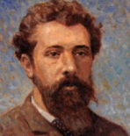
🎨 What Did Seurat Create?
Georges Seurat invented a new way of painting called Pointillism, where pictures are made using tiny dots of colour. Instead of mixing colours on a palette, he placed small dots side by side and let the viewer’s eyes mix them! His art is calm, detailed, and full of light.

👶 Childhood
- Georges was born in Paris, France in 1859.
- His family was wealthy, so he didn’t have to worry about money.
- He loved drawing from a young age.
- He had a quiet personality and spent lots of time observing and sketching.

🎓 Education
- He studied at the École des Beaux-Arts, a famous art school in Paris.
- He also learned by visiting museums and copying famous paintings.
- He was inspired by science and how light and colour work.
- He admired artists like Delacroix and the Impressionists.

🧑‍🎨 Career
- Seurat invented Pointillism, a new art style using only tiny dots.
- His most famous painting is “A Sunday Afternoon on the Island of La Grande Jatte.”
- He believed art should be scientific and carefully planned.
- He died young, at age 31, but left a big mark on modern art.

💬 Quotes from Seurat
“Some say they see poetry in my paintings; I see only science.”
“Art is harmony.”
“I want to make modern people something like the statues on the Parthenon.”
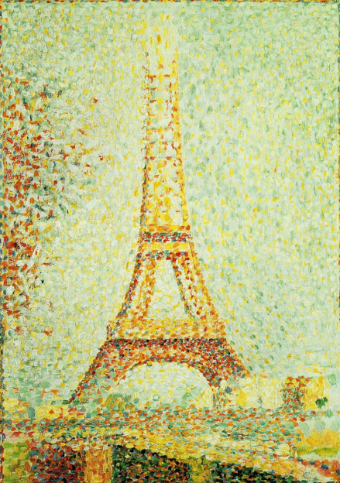
🎨Art
The Eiffel Tower
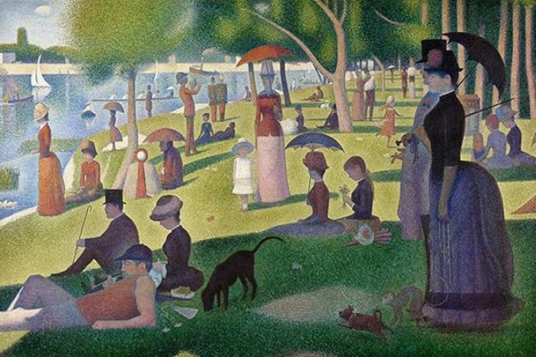

A Sunday Afternoon on The Island of La Grande Jatte
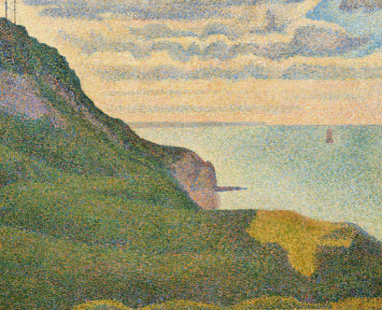
Seascape at Port en Bessin

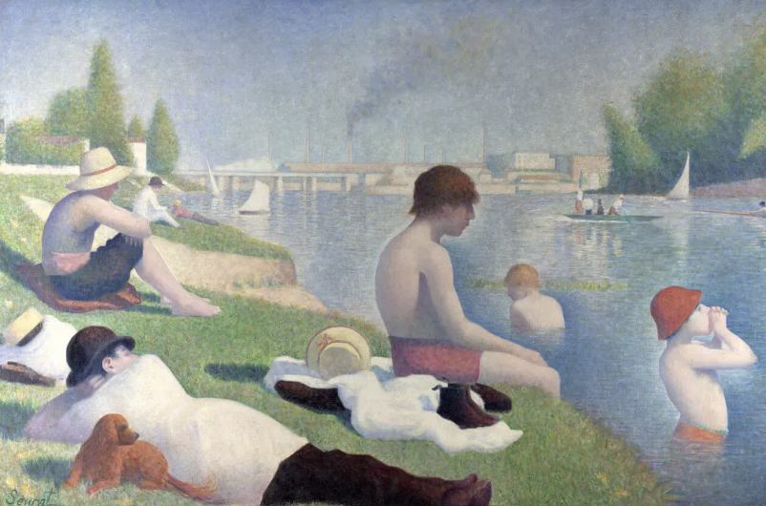

Bathers at Asnières

