Henri Rousseau
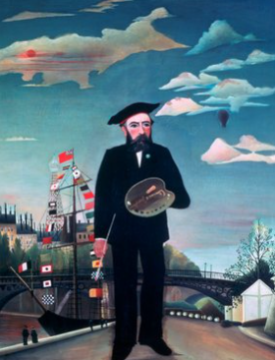
Henri Rousseau was a French artist who loved to paint magical jungle scenes, even though he never visited a real jungle! His colourful, dreamlike pictures are full of wild animals, trees, and plants, and they look a bit like storybook illustrations.

🧒 Childhood
- Henri Rousseau was born in France in 1844.
- His father was a plumber, and his family didn’t have much money.
- As a child, he liked drawing and nature.
- He played the violin and enjoyed music too.

🎓 Education
- Henri didn’t go to art school when he was young.
- He learned to paint by copying pictures and teaching himself.
- He visited museums and studied famous paintings.
- People called him a “naïve” or “self-taught” artist.
🖼️ Fun Fact:
Even though Rousseau never left France, his jungle paintings were inspired by books, visits to the zoo, and plants at the botanical gardens!

💼 Career
- He worked as a customs officer, checking goods at the city gates—so people called him “Le Douanier” (The Customs Officer).
- He painted in his spare time and didn’t become famous until later in life.
- Many people made fun of his art at first because it looked different.
- Today, his jungle paintings are loved all over the world!

🗣️ Quotes from Henri Rousseau
“When I go into the glass houses and I see the strange plants of exotic lands, it seems to me that I enter into a dream.”
“I always believe in my art.”
“Beauty is the promise of happiness.”
“I’m not copying nature, I’m expressing it.”

🎨 Art

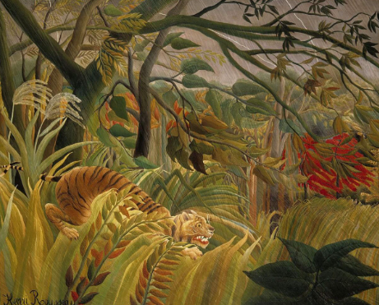
Tiger in a tropical storm
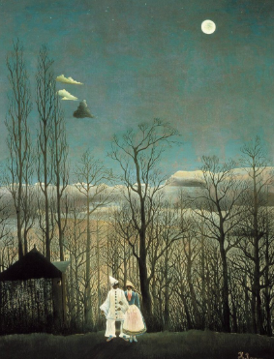

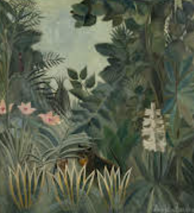
The equatorial jungle

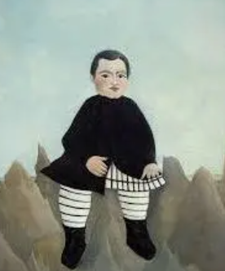
Carnival evening

Boy on the rocks

