Create your own imaginary jungle in the style of Henri Rousseau, something like this maybe – although you’re bound to have your own ideas
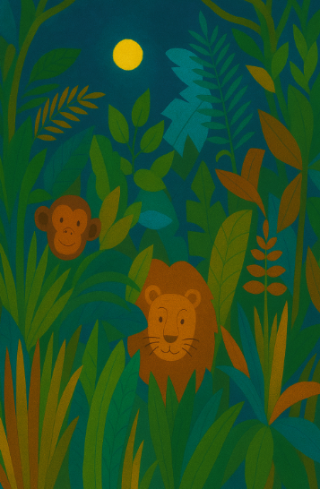

🧰 What You’ll Need
• White A4 paper
• Pencil & eraser
• Black marker or pen (for outlines)
• Colouring pencils, or markers
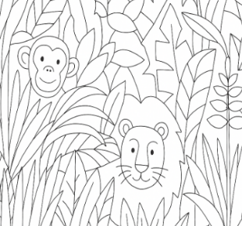
✏️ Step 1: Lightly Sketch the Background and Fill with Leaves and Plants
Sketch big leafy plants and long vines in the foreground. Add trees with tall trunks and rounded leaves reaching into the sky.
Add lots of tropical leaves—big, long, spiky, round, curly! Layer them to make it look wild and full. You can copy plant shapes from books or use your imagination.

🌿 Step 2: Add Jungle Animals
Choose one or two animals to hide in your jungle—like a tiger, monkey, or parrot. Put them partly behind the leaves, like they’re peeking out.

🎨 Step 3: Add Colour – before you start, is it day, or is it night?
Colour your jungle with rich greens, browns, oranges, and blues. Use darker colours in the background and brighter ones in front to make it pop.
Create a Dreamy Sky - Use soft blue or purple to make a magical sky. Add a glowing moon or a few fluffy clouds—Rousseau often painted full moons in his night skies.

💡 Additional Art Ideas to Explore
🦁 Rousseau never saw the animals he painted in his exotic jungles (that’s why the tiger looks so odd) he read about them and listened to stories. Ask a friend to describe an animal to you – but not to tell you which animal it is. Try to draw it from the description. Once you’ve finished, ask them what the animal is and check your illustration against pictures of the real thing.
🌳 Create a jungle collage using real leaves or green paper.
🎭 Design your own jungle story and paint each page.
🌔 Make a moonlit jungle scene with black paper and chalk.
🌸 Try drawing jungle flowers with bright patterns and colours.

