🎨 Pierre-Auguste Renoir

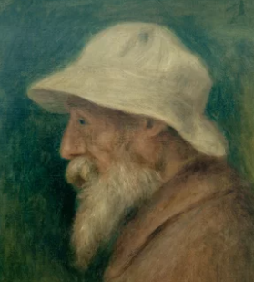
🖌️ Who was Pierre-Auguste Renoir?
- Pierre-Auguste Renoir was a famous French artist known for his beautiful, colourful paintings.
- He was one of the leading artists of the Impressionist movement and is celebrated for his vibrant, joyful scenes and portraits.
- Renoir’s paintings are known for their light, vibrant colors and soft brushstrokes.

🌱 Childhood:
- Renoir was born on February 25, 1841, in Limoges, France.
- As a child, he loved to draw on the walls of his home with chalk!
- His father was a tailor, and his family wasn't wealthy, so Renoir had to work from a young age.
- He started working as a porcelain painter in a factory when he was just 13 years old.
- He loved to sing and once thought about becoming a musician.
- As a child, he painted on the walls of his home with chalk – his first art "gallery"!

📚 Education:
- Renoir attended a local Catholic school as a boy.
- He later took evening drawing classes while working during the day.
- Renoir also studied at the studio of Charles Gleyre, where he met other famous artists like Monet and Sisley.
- He worked as a porcelain painter in a factory when he was just 13 years old.
- In 1862, he studied at the École des Beaux-Arts in Paris, a very famous art school.

🌟 Career:
- He became a leader of the Impressionist movement, which focused on light, color, and everyday life.
- Renoir painted over 4,000 works throughout his career, making him one of the most prolific artists ever!
- Later in his life, he developed rheumatoid arthritis but continued painting with brushes tied to his hands.

💬 Quotes from Renoir:
- "The pain passes, but the beauty remains."
- "One must from time to time attempt things that are beyond one’s capacity."
- "A picture must be an amiable thing, joyous and pretty – yes, pretty!"

🖼️ Art
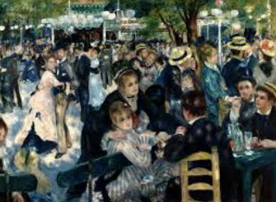
Dance at Le Moulin de la Galette
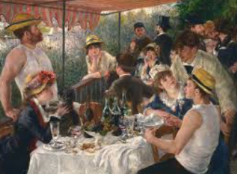

Luncheon of the Boating Party
The Swing
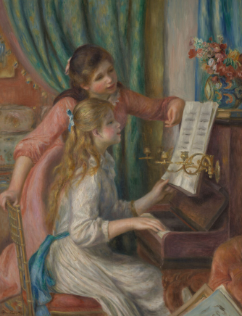
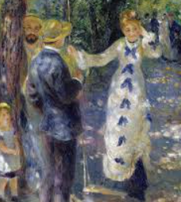
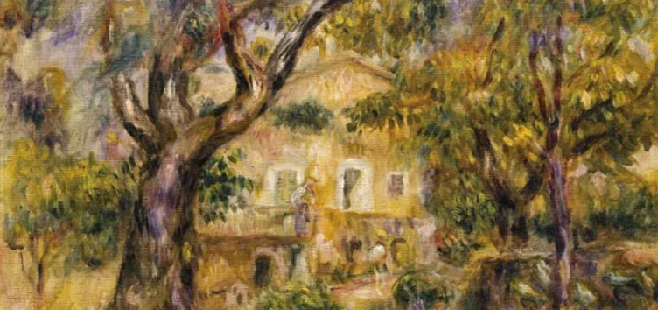
Girls at the Piano
The Farm at Les Collettes
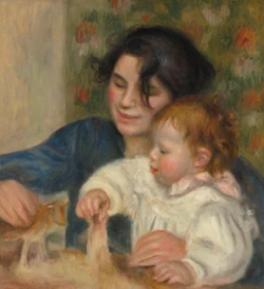

Gabrielle and Jean (his son and the nanny)

