
Draw a spiral


Add petals



Add a leaf and a stalk

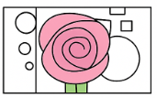

Create a panel around it, add details and colour

