Jackson Pollock
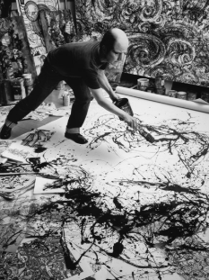

🖌️ What Did Jackson Pollock Create?
Jackson Pollock was a famous American painter who became known for his drip painting style. Instead of using a brush on an easel, he would lay his canvas on the floor and splash, drip, and swirl paint across it. His art is full of energy and emotion!

👶 Childhood
- Jackson Pollock was born on January 28, 1912, in Cody, Wyoming, USA.
- He was the youngest of five brothers.
- His family moved around a lot, and he lived in places like Arizona and California.
- He loved Native American art and sand painting, which later inspired his own style.

🎓 Education
- Jackson studied at the Manual Arts High School in Los Angeles.
- He moved to New York City to study art more seriously.
- He was trained by Thomas Hart Benton, a realist painter who taught him about rhythm and movement.
- Pollock also learned about Mexican muralists and Surrealist art, which helped shape his ideas.

💼 Career
- He worked for the Works Progress Administration (WPA), creating public art during the Great Depression.
- In the 1940s, he developed his famous drip technique.
- Pollock became a leader of the Abstract Expressionist movement.
- In 1949, Life Magazine featured him with the question: “Is he the greatest living painter in the United States?”

🖼️Artworks
Number 1A Convergence
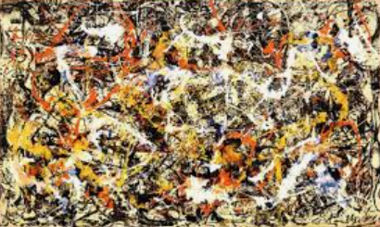
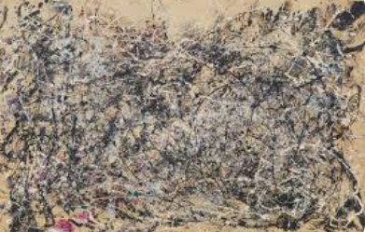

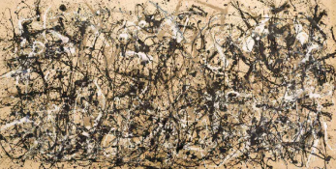
Autumn Rhythm

Blue Poles
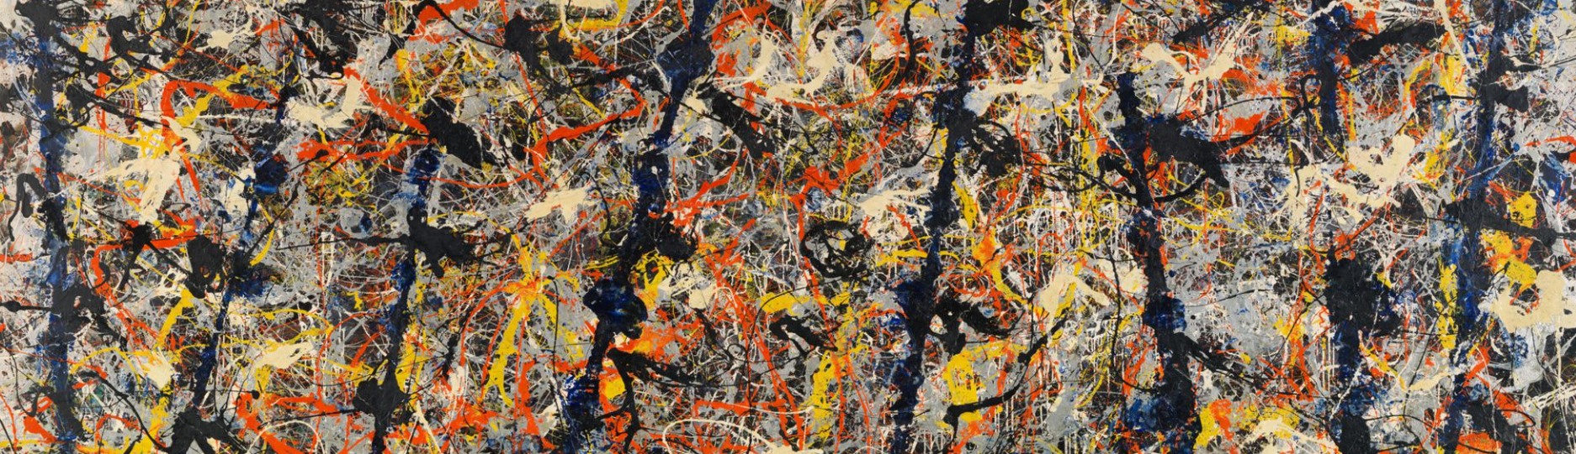
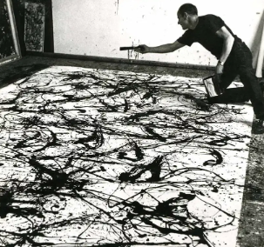

🎨How did he paint his paintings?

He used unprimed canvas and house paint, he put black lines on first, then added colour.

💬 Quotes from Jackson Pollock
- “Painting is self-discovery. Every good artist paints what he is.”
- “I don’t paint nature. I am nature.”
- “The painting has a life of its own. I try to let it come through.”

