Camille Pissarro

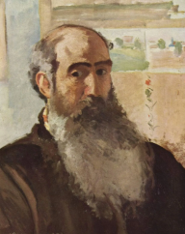
🖼️ What Did Camille Pissarro Create?
Camille Pissarro was a famous French artist known for painting beautiful outdoor scenes. He loved painting the countryside, busy streets, and quiet villages using soft, dappled brushstrokes. He was part of the Impressionist art movement and often painted how light and weather changed the look of a place.

👶 Childhood
- Camille was born on July 10, 1830, on the island of St. Thomas in the Caribbean.
- He had 4 brothers and sisters and loved exploring the island’s natural beauty.
- He liked to draw animals and tropical scenes from a young age.
- His parents sent him to school in France when he was just 12 years old.

🎓 Education
- Pissarro studied in Paris at a school where he learned to draw and paint.
- He was inspired by nature and didn’t always like following the strict rules of traditional art schools.
- He learned a lot by painting outdoors and observing how light and colour changed during the day.
- He was influenced by other artists like Gustave Courbet and Jean-Baptiste-Camille Corot.

🧑‍🎨 Career
- Camille helped start the Impressionist movement with artists like Claude Monet and Edgar Degas.
- He loved teaching and supported younger artists like Paul Cézanne and Paul Gauguin.
- He exhibited his art in all eight Impressionist exhibitions held in Paris.
- His painting style became more colourful and dotted in his later years, showing the influence of Pointillism.

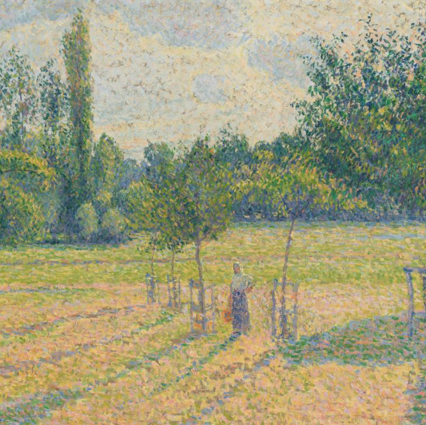
🎨 Art
Fox Hill, Upper Norwood
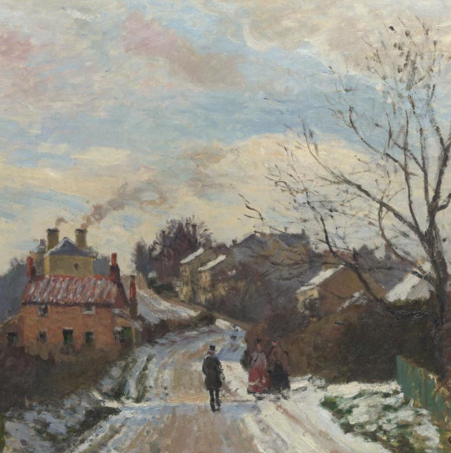

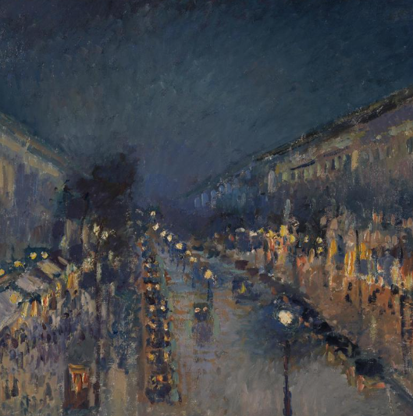
Late Afternoon in our Meadow

The Boulevard Montmartre at Night

💬 Quotes from Pissarro
“Blessed are they who see beautiful things in humble places where other people see nothing.”
“Work at the same time on sky, water, branches, ground, keeping everything going on an equal basis.”

