**Pablo Picasso**

**  
Pablo Picasso was a famous Spanish artist known for his unique and imaginative artwork. He created paintings, sculptures, drawings, ceramics, and even poetry! Picasso is considered one of the greatest and most influential artists of the 20th century.

He is well known for starting the art movement called Cubism, which uses geometric shapes to depict people and objects.

In 1909, Picasso and French artist Georges Braque co-founded an art movement known as cubism because an art critic said their work was "full of little cubes."

👶 **Childhood:**

* **Birthplace:** Picasso was born in Málaga, Spain, on 25th October 1881.
* **First Drawing:** His first word was “pencil” in Spanish (“piz”), and he loved drawing from a very young age.
* **Art from the Start:** Picasso’s father was an art teacher, and he began teaching Pablo to draw when he was just a child.
* **Child Prodigy:** By the age of seven, Picasso was already creating realistic drawings.

📚 **Education:**

* **First Formal Training:** Picasso’s father taught him the basics of drawing and painting.
* **Art School in Spain:** He attended the School of Fine Arts in Barcelona at the age of 13.
* **Academy of San Fernando:** Picasso later studied at this prestigious art academy in Madrid.
* **Learning Beyond School:** Although he attended art schools, Picasso always experimented on his own and developed his unique style.

🎨 **Career:**

* **Prolific Artist:** Picasso created over 20,000 artworks during his lifetime, including paintings, drawings, sculptures, and ceramics.
* Pablo Picasso held his first exhibition at the **Els Quatre Gats (The Four Cats)** café in **Barcelona, Spain**, in **1900**. This café was a popular meeting place for young artists. The exhibition featured his early works, created during his teenage years. This show helped Picasso gain early recognition in the local art scene before he moved to Paris

**🖼️ Key Parisian Supporters of Picasso**

Picasso had a lot of help to achieve his dream, individuals and institutions provided Picasso with the necessary support, exposure, and environment to develop his groundbreaking artistic style and gain recognition in the art world

* The **Bateau-Lavoir** was a communal building in Montmartre where Picasso lived and worked during his formative years in Paris. It served as a creative hub for many artists and writers, fostering collaboration and innovation. The environment at Bateau-Lavoir was instrumental in Picasso's artistic development.
* In 1901, art dealer **Ambroise Vollard** organized Picasso's first major exhibition in Paris, showcasing his early works and marking a pivotal moment in his career. Vollard's gallery was known for promoting avant-garde artists, and his support provided Picasso with critical exposure to the Parisian art scene.
* **Berthe Weill** was a pioneering French art dealer who played a crucial role in Picasso's early success. She provided him with exhibition opportunities and facilitated some of his first sales in Paris. Weill's gallery was instrumental in introducing emerging artists to collectors and the public.
* In 1907, **Daniel-Henry Kahnweiler**, a German-born art dealer based in Paris, became one of Picasso's most important patrons. He signed an exclusive contract with Picasso, providing him with financial stability and promoting his work internationally. Kahnweiler's support was vital in the development and dissemination of Cubism.
* American expatriates **Gertrude and Leo Stein** were among Picasso's earliest collectors in Paris. Their salon at 27 rue de Fleurus became a hub for artists and writers, offering Picasso both patronage and a network of influential contacts. Gertrude Stein's support, in particular, helped elevate Picasso's profile among art connoisseurs.

🖼️ **Famous Artworks by Picasso**

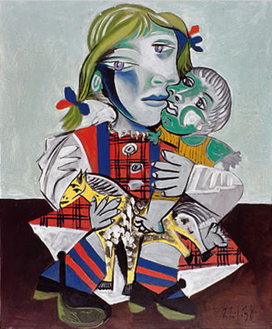Before you look at Picasso’s artwork, you have to understand the way he worked.

**He painted what he saw – exactly what he saw!**

For example, when he painted **Girl with Doll** the little girl was moving around playing with her toys, but he didn’t ask her to sit still, instead, he painted all the versions of her that he saw.

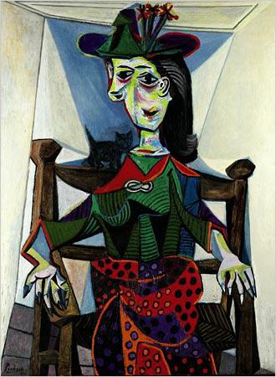**He could capture a moment.**

While he was painting Dora Maar her kitten jumped onto her shoulder. In an instant, Picasso captured the moment, as a result, Dora has a two-sided face, one looking at her cheeky kitten, the other looking at the painter. **Dora Maar au chat** is an unusual portrait!

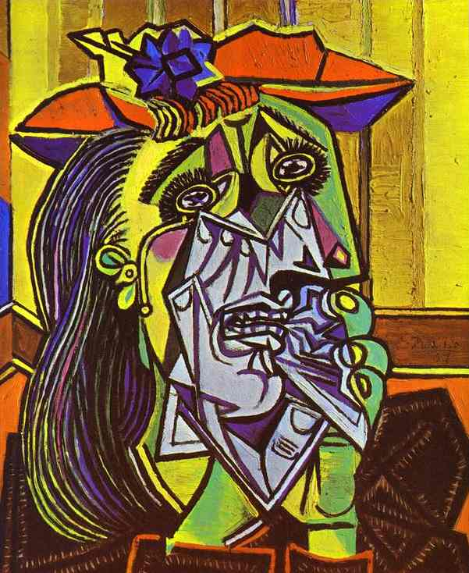

**He saw what was inside**

He empathised with people so much he could draw their emotions. In **The Weeping Woman** the poor sad lady had lost her baby, but she tried to hide the sad grey part of her inside by wearing bright clothes and a colourful hat. Picasso saw through her external façade, and he also painted the sadness underneath.

His ability to paint feelings and sadness led to one of his most famous paintings, the mural **Guernica**. Painted in black and white and greys, it tells the story of the bombing of this small town.

It is considered one of the most important anti-war paintings of all time.

He had a **Blue period** from 1901-1904, when he was poor and depressed and he had the blues; he used blues and blue greens, and his paintings were sad.

**Femme aux Bras Croisés**

He then had a **Rose Period**, just after the Blue Period, when he started to feel better; his paintings are much more upbeat and feature a lot of acrobats and athletes, which demonstrates his renewed energy. He created these paintings in colours of red, pink and orange.

**Family of Saltimbanques**

**Sculpture**

He also moved more towards abstract styles during this phase, especially in his sculptures.

Here he is with an abstract statue **La Femme au Jardin,** in Paris