Berthe Morisot
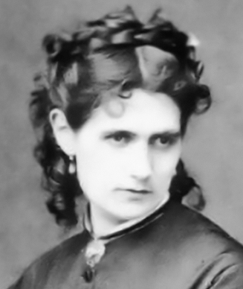
Who was Berthe Morisot?
Berthe Morisot was a famous French artist who painted in the Impressionist style. She loved to show gentle, everyday moments like mothers with children, people in gardens, or women sitting quietly indoors. She used soft brushstrokes and light colours to create a feeling of sunshine, movement, and emotion in her art. Morisot was one of the only women in the group of artists who started the Impressionist movement.

👧 Childhood
- Born in France in 1841 into a rich and artistic family
- Enjoyed drawing and painting from a young age
- Had two older sisters and often painted with them
- Inspired by her great-uncle, who was a well-known artist

🎓 Education
- Girls couldn't go to art school then, so she had private art lessons
- Learned to paint by copying famous artworks in the Louvre Museum
- Studied with Camille Corot, who taught her how to paint landscapes
- Practised painting outdoors, which helped her develop the Impressionist style

🖼️ Career
- The only woman who took part in the very first Impressionist art show in 1874
- Painted many pictures of her daughter and family life
- Married Eugène Manet, the brother of artist Édouard Manet
- Known for using soft colours, quick brushstrokes, and painting scenes full of light

💬 Quotes from Berthe Morisot
"Real painters understand with a brush in their hand."
"It is important to express yourself... provided the feelings are real."
"I don’t think any man would ever treat a woman as his equal, and it’s all I would ask, because I know my worth."
"My ambition is limited to the desire to capture something transient, and yet beautiful, which I think makes art worthwhile."

🎨Art

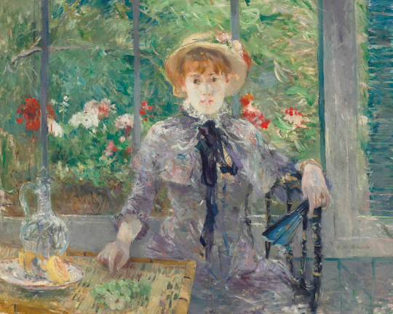

Apres le dejeuner
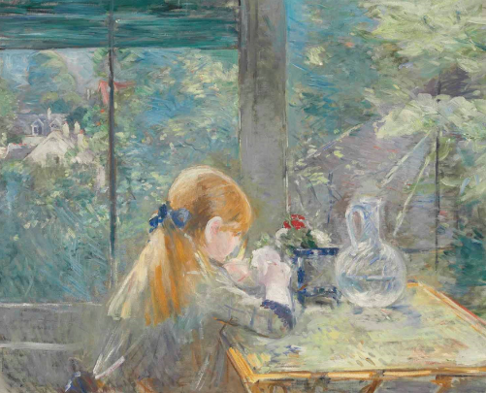
Dans la veranda

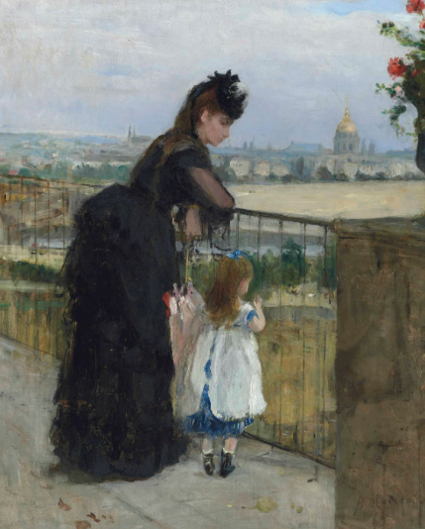

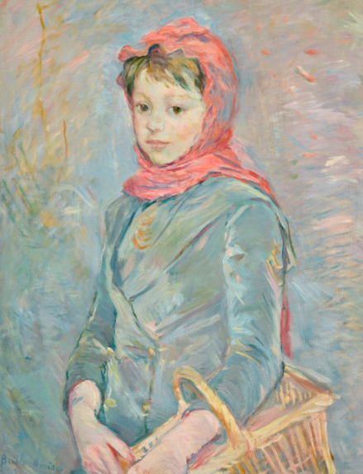
Femme et enfant au balcon

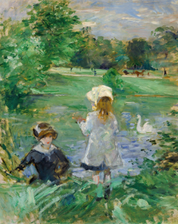
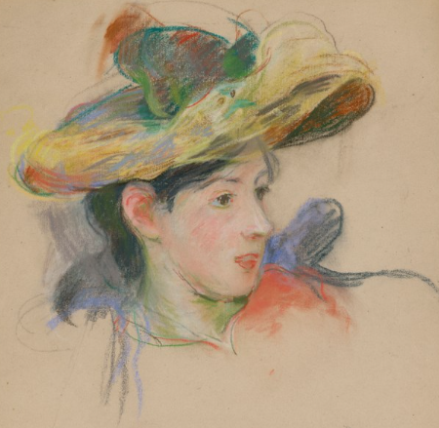
Fillette portant un panier

By the lake

Jeanne Pontillon au chapeau

