Claude Monet

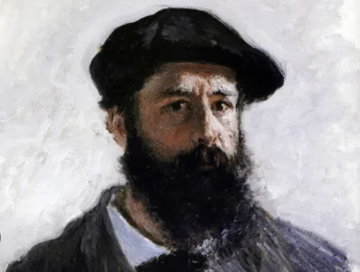
👨‍🎨 Who Was Claude Monet?
Oscar-Claude Monet was a famous French artist who painted beautiful scenes of nature like gardens, water lilies, and the sea.
He helped start a new style of painting called Impressionism, where artists used light and colour to show how something felt instead of painting it exactly as it looked.

🧒 Childhood
- He was born on November 14, 1840, in Paris, France.
- His father, Adolphe Monet, ran a family grocery and ship-supply business in Le Havre.
- His mother, Louise-Justine Aubrée Monet, was a singer who supported Claude’s artistic interests.
- After his mother died when he was 16, Claude moved in with his aunt, who also encouraged his art.
- As a child, he loved to draw funny pictures (caricatures) of people.
- He grew up near the sea in Le Havre, where he watched ships and water every day.

🎓 Education
- Monet went to secondary school (Collège Secondaire des Arts) in Le Havre, where he took art classes.
- He received his first drawing lessons from Jacques-François Ochard, a former student of Jacques-Louis David.
- He studied at the Académie Suisse in Paris and later joined the École des Beaux-Arts briefly, though he disliked their strict, traditional methods.
- He was mentored by Eugène Boudin, who taught him to paint outdoors (“en plein air”), which became a key part of Impressionism.
- At 15, he was already selling his caricatures for pocket money.
- He joined the army but left because he got sick, then went back to studying art seriously.

💼 Career
- Impressionism was born from his painting Impression, Sunrise (1872). The name was originally used as a joke by a critic!
- He painted the same subject many times—like haystacks or the Rouen Cathedral—to show how it looked in different lights and seasons.
- He loved painting outdoors (en plein air) with quick brushstrokes and bright colors.
- He formed an art group with friends like Renoir and Pissarro to display their work outside official galleries.
- Monet faced money troubles early in his career, but by the 1880s, his art became popular and he began to make a good living.
- In his later years, Monet designed and planted a huge flower garden and lily pond in Giverny. These became the subjects of some of his most famous works.

🗣️ Quotes from Monet
- “I must have flowers, always, and always.”
- “Colour is my day-long obsession, joy and torment.”
- “I perhaps owe having become a painter to flowers.”
- “Everyone discusses my art and pretends to understand, as if it were necessary to understand, when it is simply necessary to love.”

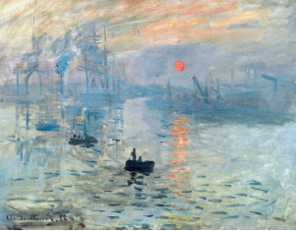
🖼️ Artwork
Impression, Sunrise (1872)

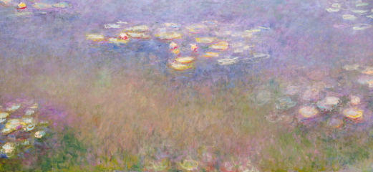
Water Lilies a series of 250 different paintings(1897–1926)

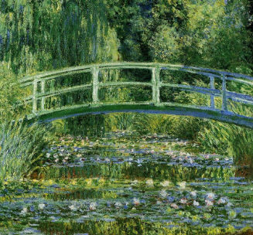
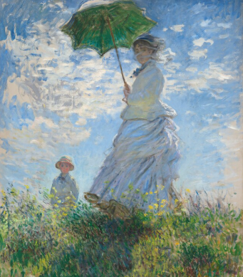
The Japanese Bridge
Woman with a Parasol (1875)

