Piet Mondrian
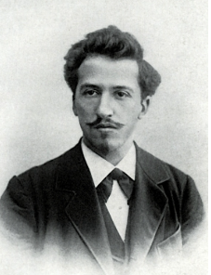

🖌️ What Did Mondrian Create?
Piet Mondrian was a Dutch artist best known for creating abstract art using straight black lines and blocks of red, yellow, blue, white, and black. His style is called neoplasticism or De Stijl, which means "The Style" in Dutch. His artwork looks like colourful grids or puzzles!

👶 Childhood
- Piet Mondrian was born on March 7, 1872 in the Netherlands.
- His father was a teacher and a church painter—Mondrian started drawing with him as a child.
- He loved nature and often painted trees, flowers, and windmills when he was young.
- Mondrian was very quiet and serious, even as a little boy.

🏫 Education
- He studied art at the Academy for Fine Art in Amsterdam.
- His early paintings were very realistic, like landscapes and still lifes.
- He was inspired by other artists like Van Gogh and Cezanne.
- He later explored cubism, then moved to complete abstraction—just shapes and colours!

🎨 Career
- He moved to Paris in 1911, where he was influenced by modern art and cubism.
- In 1917, he helped start the De Stijl art movement.
- He moved to New York City in 1940, where he added movement and rhythm to his art.
- One of his most famous works is “Composition with Red, Blue and Yellow”.

🎨 Artwork
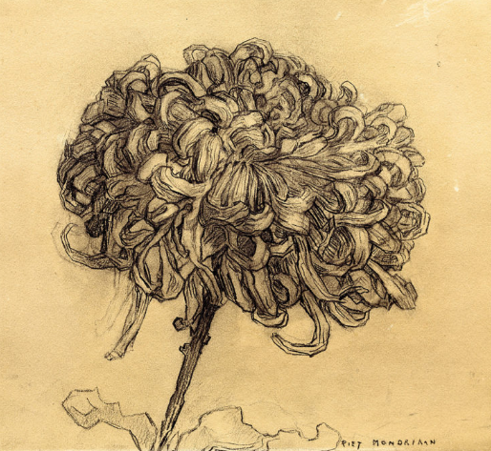

Chrysanthemum

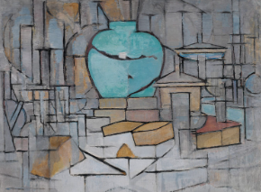
Still life with ginger pot

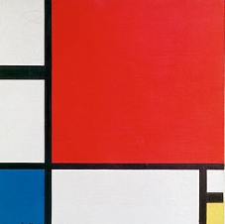

Composition in Red, Blue and Yellow

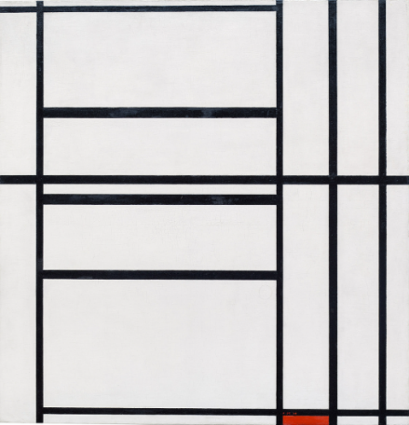

Ocean 5

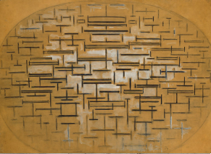
Composition number 1, in Grey and Red

🗣️ Quotes from Mondrian
"I wish to approach truth as closely as is possible."
"The emotion of beauty is always obscured by the appearance of the object. Therefore, the object must be eliminated."
"Art is higher than reality and has no direct relation to reality."

