Creating art in the style of Mondrian Composition with Red, Blue and Yellow
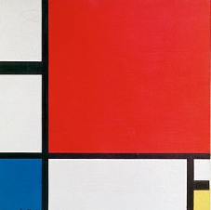

You will need:
- A ruler
- A pencil
- A black marker
- Red, blue, and yellow colouring pens or paints
- White paper (A4)

Step 1: Draw a Border
Draw a big rectangle or square on your paper. This is your art space!
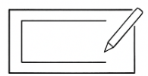

Step 2: Add Straight Lines
Use a ruler and pencil to draw horizontal and vertical lines across your page. Make different-sized squares and rectangles, something like this one, but make the lines where you want them.
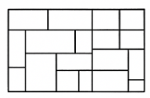

Step 3: Trace Over Lines
Use a black marker or paint to go over your pencil lines. Make them thick like in Mondrian’s art.

Step 4: Colour In
Colour some of the shapes red, blue, or yellow. Leave some shapes white—don’t colour them all in!

