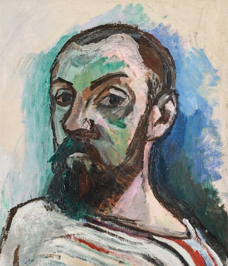
👨‍🎨 Who Was Henri Matisse?
Henri Matisse (say: "On-ree Ma-tees") was a famous French artist. He painted bright, colourful pictures and made amazing cut-out art too! Matisse loved using bold shapes and cheerful colours that made people smile.

👦 Childhood Facts
- Henri Matisse was born on December 31, 1869 in a small town in France.
- As a child, he didn’t plan to be an artist — he wanted to be a lawyer!
- He didn’t start painting until he was in bed sick one day as a young adult. He tried painting to pass the time… and he loved it!

🎓 Education and Art Style
- Matisse went to art school in Paris to learn how to paint.
- At first, he painted in dark colours, but later he became known for using bright, bold colours.
- He helped start a style of art called Fauvism — that means "wild beasts" in French because the colours were so wild and bright!
- Later in life, when he got too ill to paint with a brush, he used scissors to make cut-out pictures called collages.

- 💡 Fun Matisse Facts
- He loved music and often painted while listening to it.
- His house and studio were filled with flowers, patterns, and bright fabrics.
- People say his art makes you feel joyful, dreamy, and full of colour.
- He once said, “There are always flowers for those who want to see them.”

🖼️ Famous Works
Here are some of his most famous artworks:
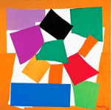
- 🎨 "The Snail" – A big colourful spiral made from paper shapes.

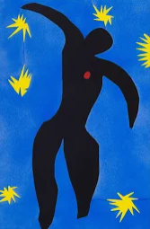

- 🎨 "Icarus" – A black figure with stars around him, showing a story from Greek mythology.

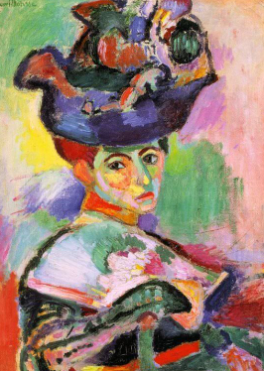

- 🎨 "Woman with a Hat" – A portrait of his wife using wild colours!

