Create an Art Nouveau panel like Margaret’s

🌸 Materials:
- A sheet of thick paper or card
- A pencil
- A black pen
- Glitter glue, cotton wool, or string for raised texture
- Watercolour paints or coloured pencils

✏️ Step 1: Draw a Dreamy Face
Start by sketching an oval face with closed eyes and a calm expression in the centre of your page.
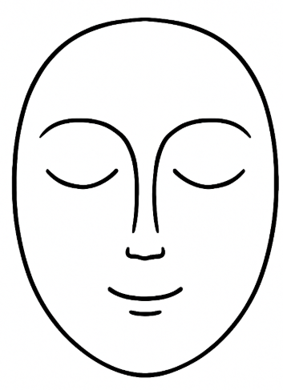 Copy this one if you want

🌿 Step 2: Add Long, Flowing Hair
Draw long, wavy lines from the head down to the bottom of the page. Let them twirl and curl like ribbons.
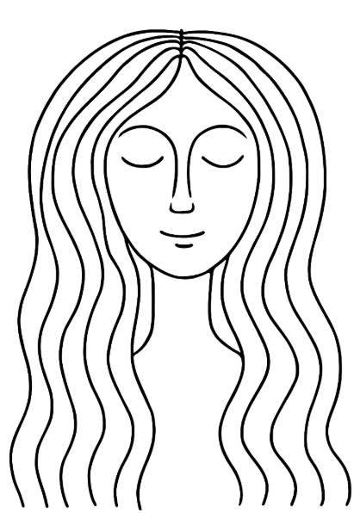 Maybe like this?

🌸 Step 3: Decorate with Nature
Add flowers, leaves, and stars in the hair and background. You can use shapes like teardrops, circles, and ovals.
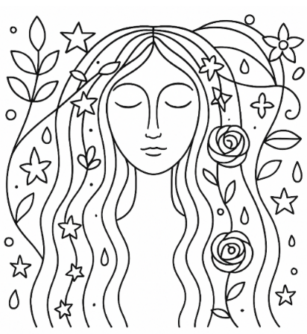
Maybe like this? Your illustration choices will be different, but we do recommend some Mackintosh roses somewhere.

✨ Step 4: Add Texture
Use glitter glue, cotton wool, or string to go over some of the lines or shapes to make them raised, like Margaret’s gesso panels.

🎨 Step 5: Add Colour
Use soft, dreamy colours like lilac, pale blue, peach, or gold. Colour gently to keep the design light and floaty.

