Margaret Macdonald Mackintosh
An Artist of Whimsy, Pattern & Dreams

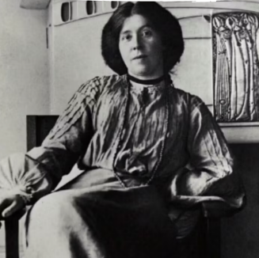
🖌️ What Did Margaret Create?
Margaret Macdonald Mackintosh was a Scottish artist who made magical, dream-like art. She made:
- Beautiful paintings with flowing shapes and mysterious faces.
- Panels and murals using metal, fabric, and paint.
- Delicate gesso reliefs (a kind of raised decoration on panels).
- Art for buildings and interior designs, often working with her husband, architect Charles Rennie Mackintosh.

👧 Childhood
- Margaret was born in Tipton, England in 1864.
- She moved to Scotland with her family as a young girl.
- She had a close bond with her sister, Frances, who also became an artist.
- Margaret loved nature, fairy tales, and dreams—themes that later inspired her art.

🎓 Education
- Margaret went to the Glasgow School of Art in the 1890s.
- She studied design and decorative arts, like metalwork and textiles.
- She worked closely with her sister Frances at school.
- Together they formed a group with two other students called “The Four.” The group they formed included Margarets’ husband Charles Rennie Mackintosh, and Frances’ husband Herbert MacNair

🌟 Career
- Margaret became known for her unique Art Nouveau style, full of swirls, curves, and symbolic images.
- She made many gesso panels for exhibitions and homes, including for Miss Cranston's tea rooms in Glasgow.
- She worked often with her husband, designing the interiors of his famous buildings.
- Her work inspired artists across Europe and helped shape modern art.

💬 Quotes from Margaret
“Art is the flower — life is the green leaf.”
“A design must come from within.”

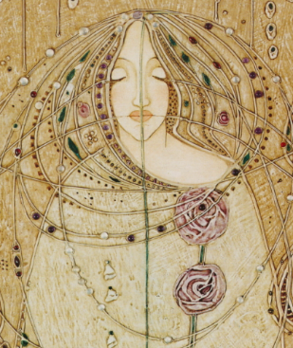
🎨 Art

‘Homage to the Seven Princesses’ – detail #4 a gesso panel from a series commissioned for the Waerndorfer villa in Vienna

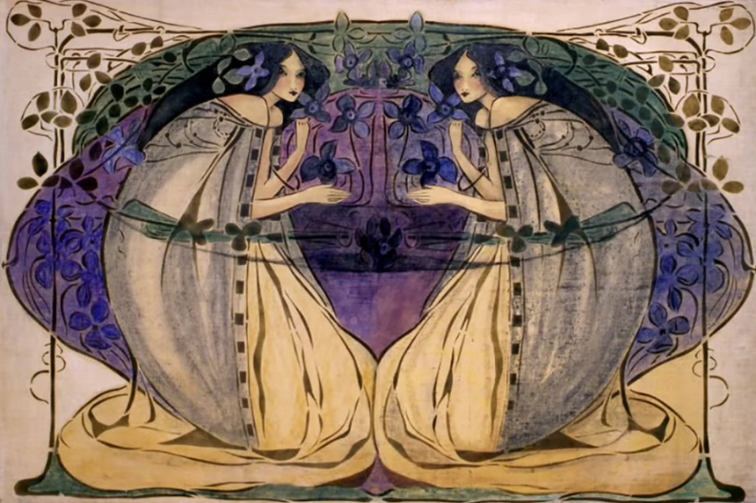

‘Spring’ part of a series of 4 created for the home of H. H. Blackie

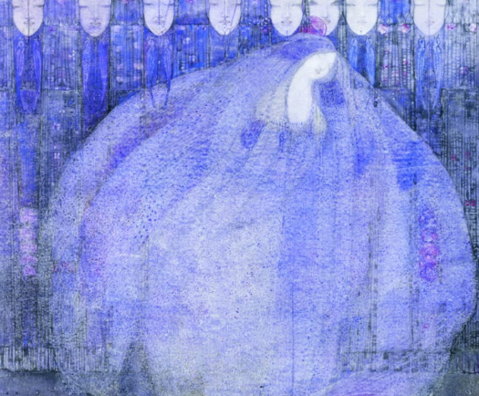

The Mysterious Garden – a watercolour

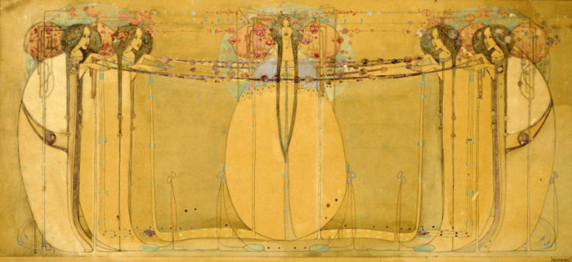
‘The May Queen’
- a three-panel oil painting on gesso commissioned for the Ladies Luncheon Room at Miss Cranston's Tea Room

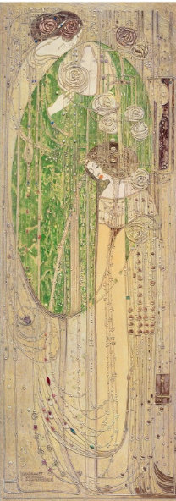
‘O ye, all ye that walk in Willow Wood’
A Gesso panel commissioned by Miss Cranston’s tea rooms as the focal point of the Salon de Luxe within the Willow Tea Rooms

